


Version 2.0.0.2





Finished Vehicle Supply Chain Mobile App
for iOS and AndroidTM

Contents
Finished Vehicle Supply Chain Mobile App 1
FVSMobile iOS/Android App Overview 3
Download and Versioning 3
Platforms 3
Security and Permissions 3
Navigation and Layout 4
Module Menus 4
Contacting Support 5
Yard Management 6
Vehicle Search 6
Vehicle Details (VIN Search Results) 7
VIN Main 7
Events 7
Work Orders (Accessorization) 8
Vehicle Inspections 8
Vehicle Transit History 9
Vehicle Documents 9
Image Upload 11
Yard Management Prebay Monitor 12
Settings 12
Recent VINs 14
Total Inventory Report 14
Yard Activity Summary Report 15
Rail Services 16
Rail Loading Summary 16
Rail Loading Dashboard 17
Damage Prevention 18
Vehicle Inspection Search 18
Transit History 19
CSX21 Report VASCOR Sign-Off 21
Inspection Exceptions (PDT Rejects) 22
Possessors In-Transit 23
Recent VINs (Damage Prevention) 23
Settings 24
Inspection Volume Report 25
Supply Chain Services 26
Load Search 26
Load Details 27
Build Load 27
Additional Information 30
Barcode Scanner 30
Android 30
iOS 31
Feature and Enhancement Requests 31

FVSMobile iOS/Android App Overview

Download and Versioning
FVSMobile v1.6.0.5 is in Evaluation Status. The app can be downloaded for iOS and android from the VASCOR system located at:
https://fvscms.vascorltd.com/mobile/FVS
The download website will maintain information about the currently released version of the app. The app will notify users if a newer version is available, and will direct the users to the download website with the click of a button on the notification alert.

Platforms
FVSMobile is currently available for iOS and android devices (phone and tablet sizes) that support a minimum operating system:
- iOS version of 6.0 and higher. Apple’s current release of iOS is 8.2 at time of documentation.
- Android version 4.2 and higher. Android current release is 5.1 at time of this documentation.

Security and Permissions
Access to FVSMobile is restricted to users with VASCOR Application Security Privileges. Privileges can be obtained with a standard VASCOR Account Update Form sent to ITServices. When the app opens on a device, the user is required to enter a username and password for a VASCOR account.
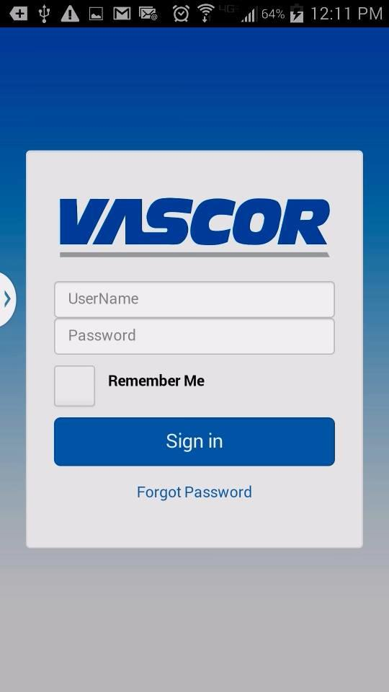
Remember Me Saves the user’s login credentials to the device and will automatically log the user into the system when they open the app.
To reset password, enter account username, then click ‘forgot password’. The system will email the account owner with the temporary password for reset process.

Navigation and Layout
The menus for the FVSMobile app are driven by security permissions granted to the authenticated user account. To access to the root system menu, click the menu icon in the top left corner.
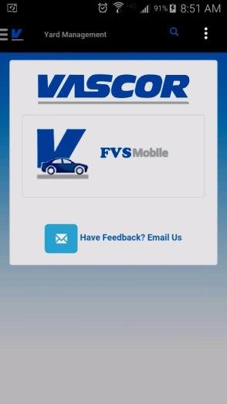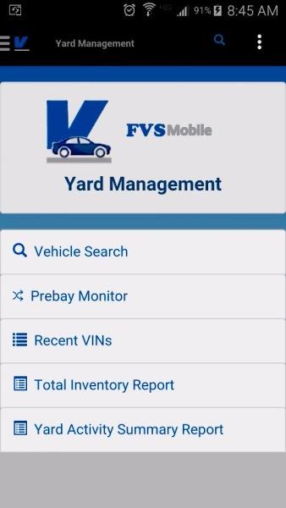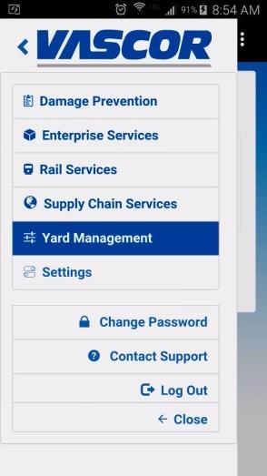
Click here to open root menu.
Click the application name to return to the landing menu.

Module Menus
After selecting a root module from the main menu, such as Yard Management, the module menu (top right) updates with the menu items the currently authenticated user account has access to within that root.
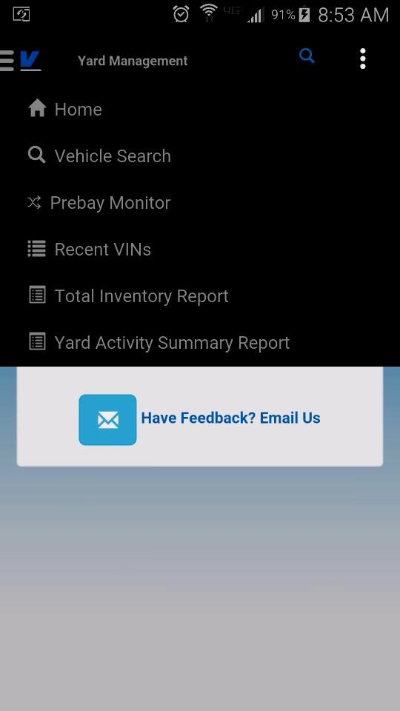
Click here to open module menu.
Click here to search inside of an application.

Contacting Support
From the Root menu, every user will have the option to Change their Password, Contact Support and Logout. The contact support page will provide the user the ability to Call, Email or visit the help desk webpage directly from the mobile application.
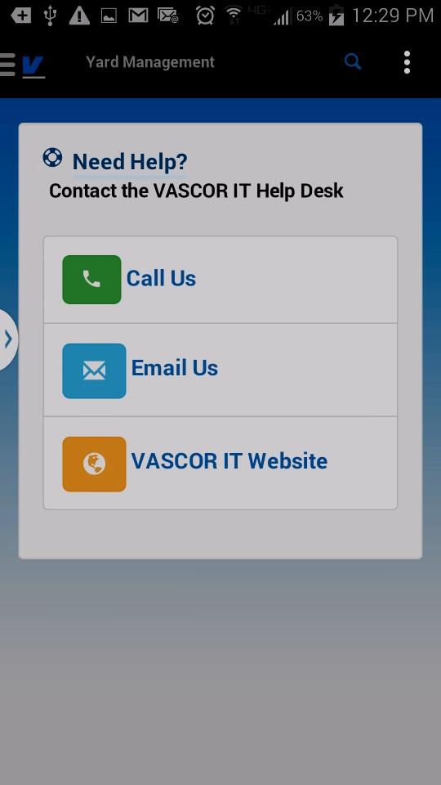

Yard Management

Vehicle Search
To search for a vehicle under Yard Management, click the magnifying glass icon on the top menu bar.
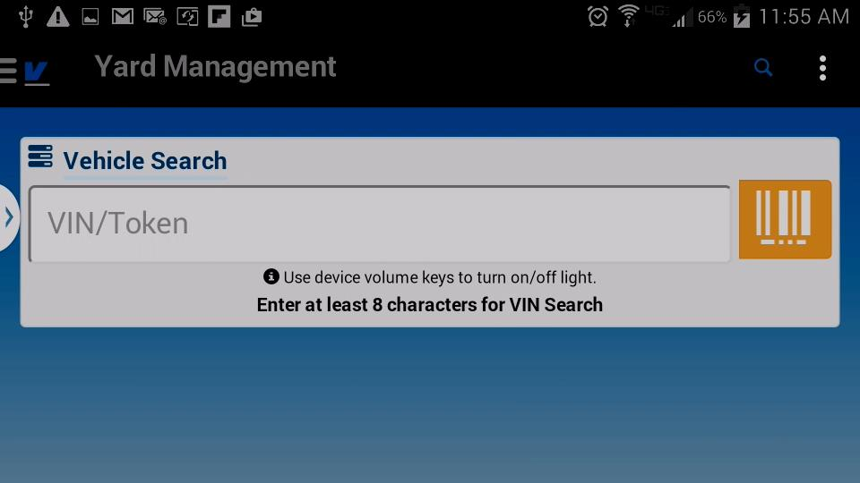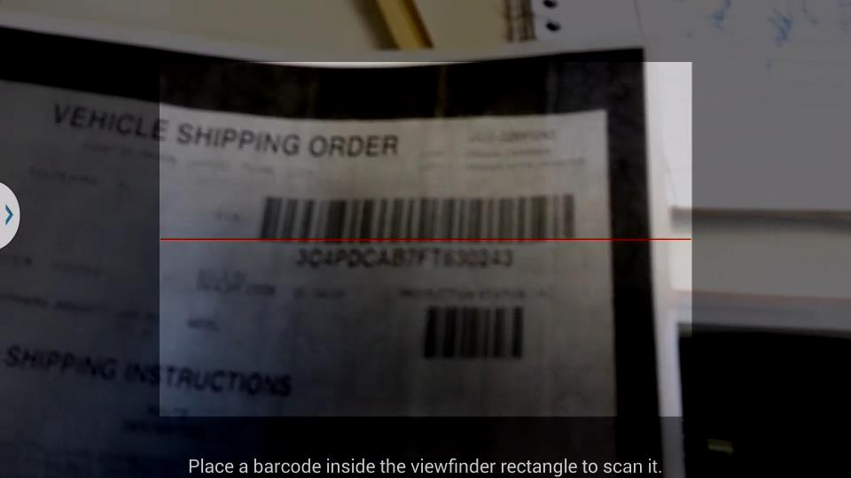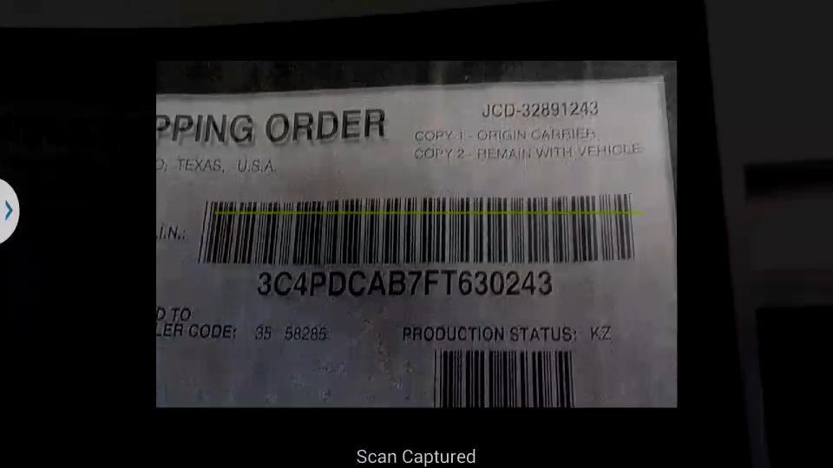
Touch the barcode button to open the barcode scanner. You can also type in the VIN/Token or last 8 characters of the VIN to search.
Follow the onscreen directions for the barcode reader. Android users may use the device volume keys to turn on the device flashlight while camera is open.
When scan is successful, the camera will automatically close and populate the VIN/Token Field.

Vehicle Details (VIN Search Results)
The vehicle details screen for yard management contains information modules that the user’s account has access to view. Swipe screen left/right to go through details, or click the header links. Possible options at this time include:

VIN Main
  - Current Vehicle Status
  - Current Yard Location/ Destination City & State /Route Code
  - Current Vehicle Holds (click “ON HOLD “ to expand for details)
  - Next Destination
  - Dealer Information
  - Currently Allocated Carrier
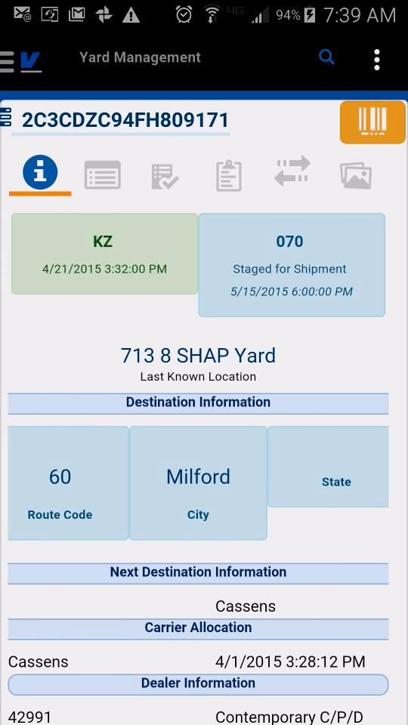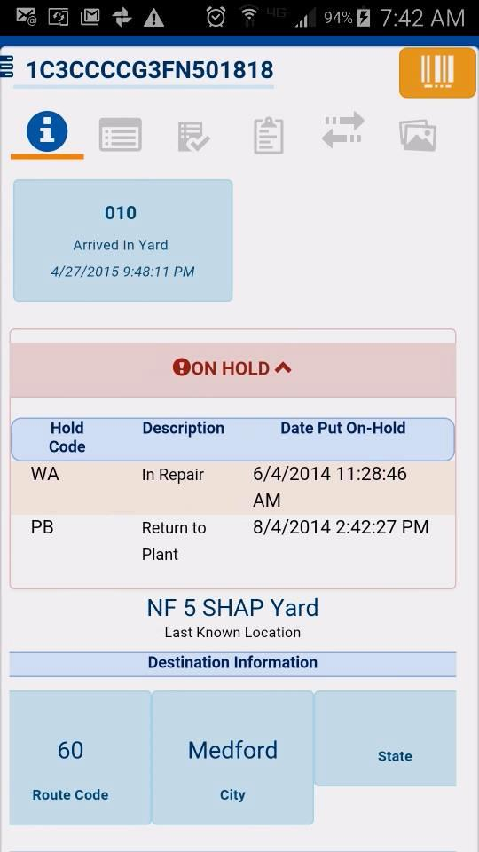
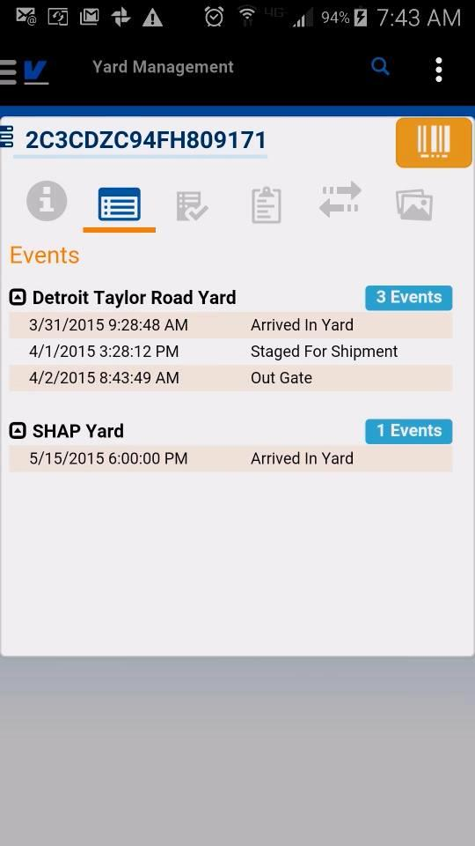

Events
  - Grouped by Location, ordered by date

Work Orders (Accessorization)
  - Pending/Completed work orders for the vehicle
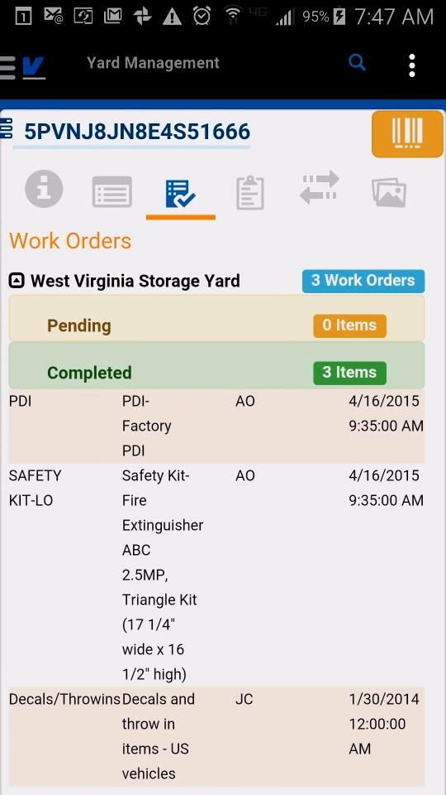

Vehicle Inspections
  - All inspections grouped by location, ordered by date
  - Inspections are color coded according to max damage severity, blue is informational, yellow and red denote damage.
  - Click Locations to expand/collapse inspections list
  - Click Inspection Header to view Damage details
  - Shows whether EDI has been sent for the inspection
  - If User has appropriate privileges, they can click to expand EDI Sent to view the list of transmissions and acknowledgements from the partner.
  - View the CSX21 Report associated to the inspection (locked by permission)
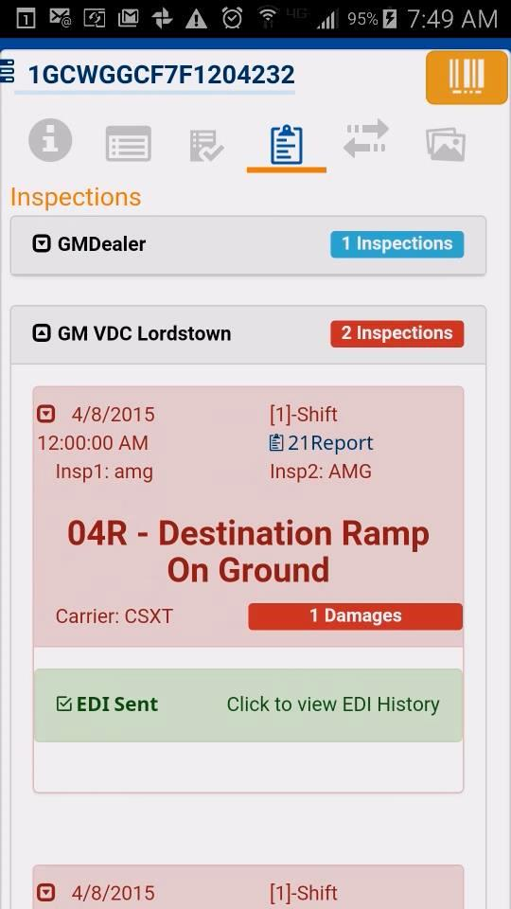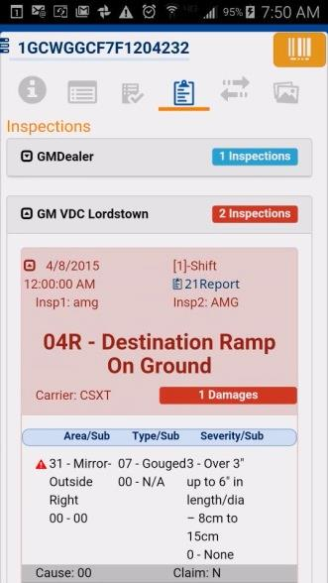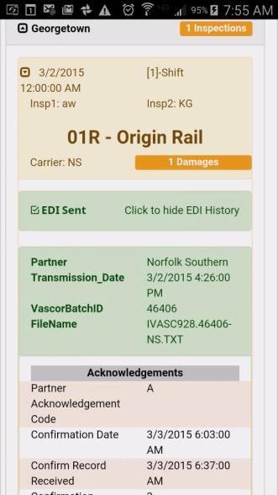

Vehicle Transit History
- Shows full transit history for a vehicle, combination of driveaway events, damage prevention possessors and loads.
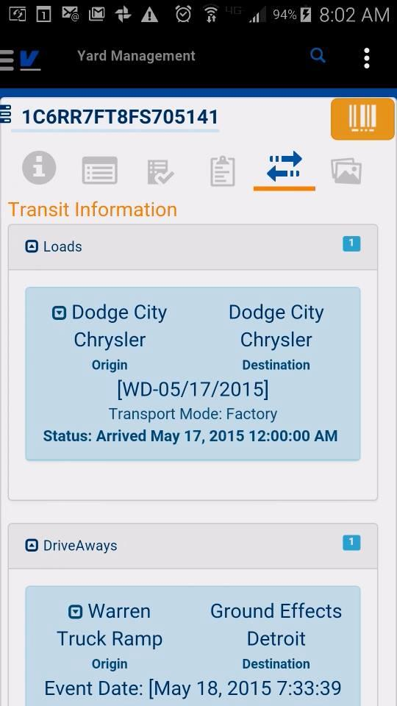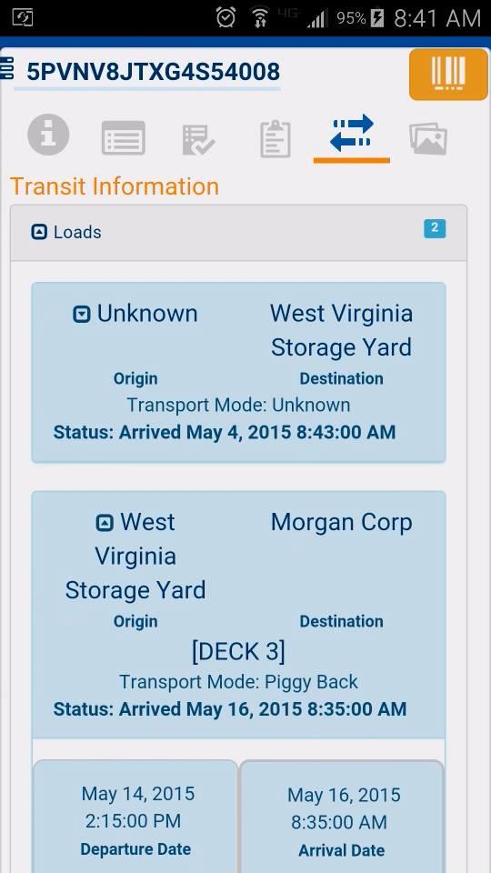

Vehicle Documents
Users with ECM privileges will be able to view and upload existing images/documents from device to the VASCOR Enterprise Content management system. The documents tab will contain all images and documents associated to the VIN including electronic proof of delivery signatures, damage images, etc. On initial load, the Image viewer displays the thumbnails of the images and when clicked, the slide viewer will display all document meta-data attached to the image, including the GPS coordinates of the signature capture/mobile image upload. Clicking the GPS coordinates will open the maps application or mobile internet browser to the maps coordinate of the upload. Clicking on the image in the slide viewer will open the image in the local device image viewer with the ability to zoom.

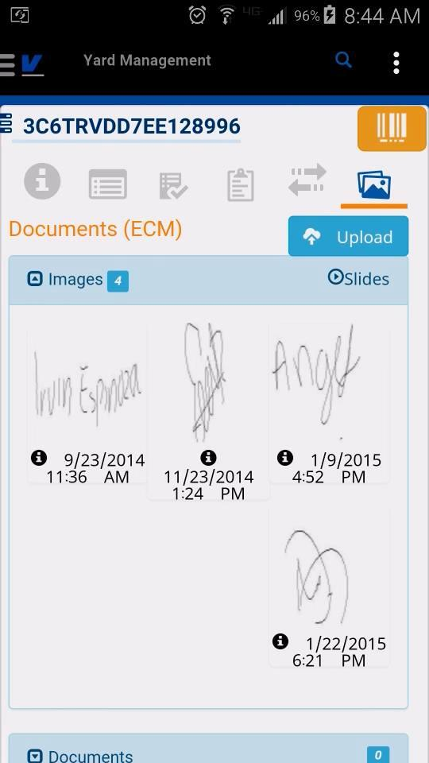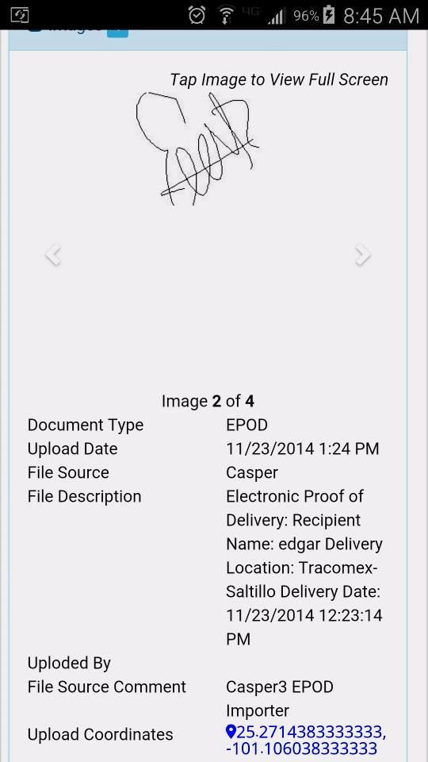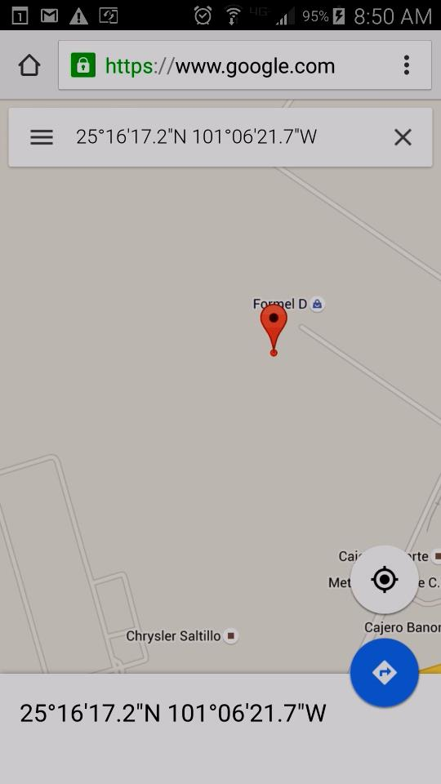

Image Upload
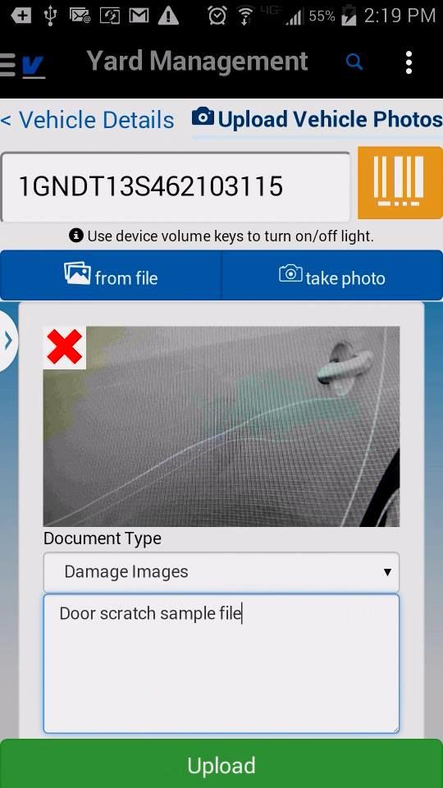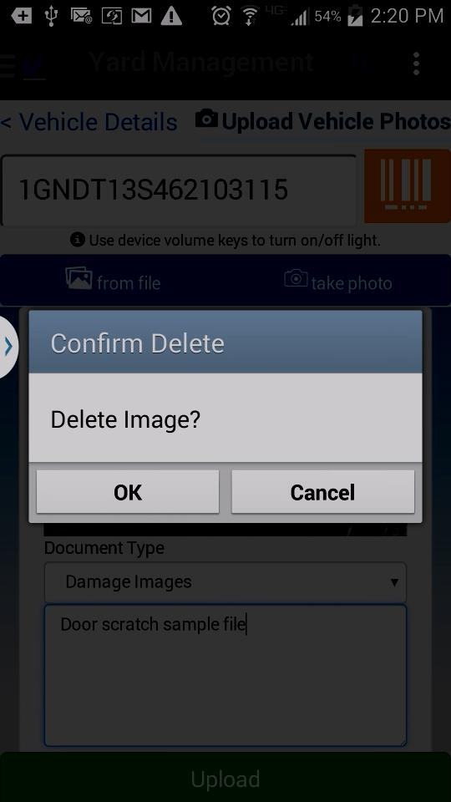
Select/capture one or more images, select document type and enter comment for each image. Click upload to send to FVSCMS ECM.
Swipe over image or click red X to delete an image from the list.
Click the Upload button to take a photo or select image from device.

Yard Management Prebay Monitor
FVSMobile Prebay Monitor is an app version of the FVSCMS Website Prebay monitor screen which shows the user dashboard information for VASCOR Prebay Locations. The user’s account must have one or more prebay preferred locations saved to view the monitor. Preferred locations can be updated and added from the Settings module under the root system menu.
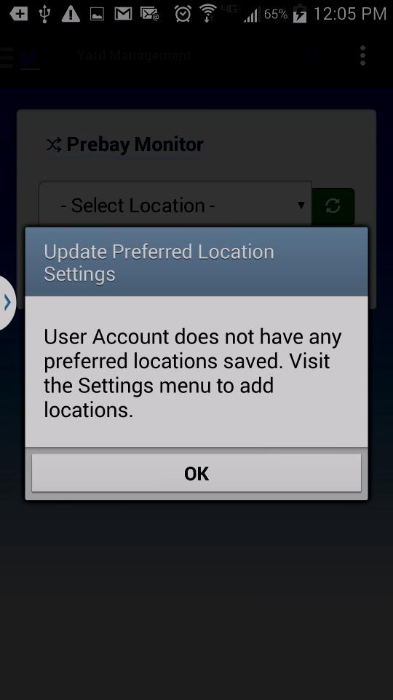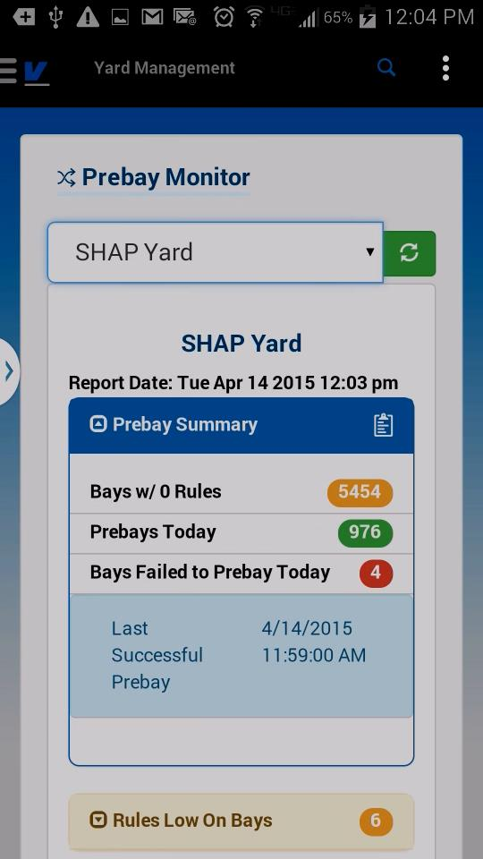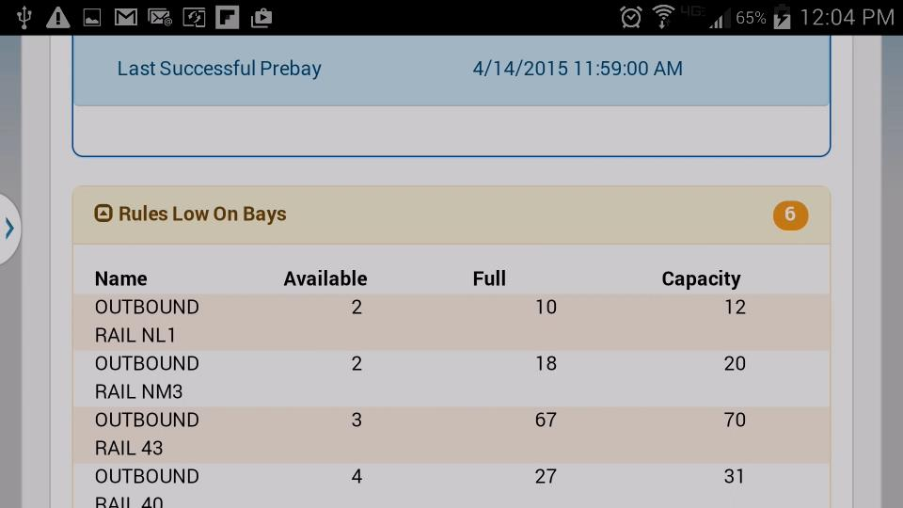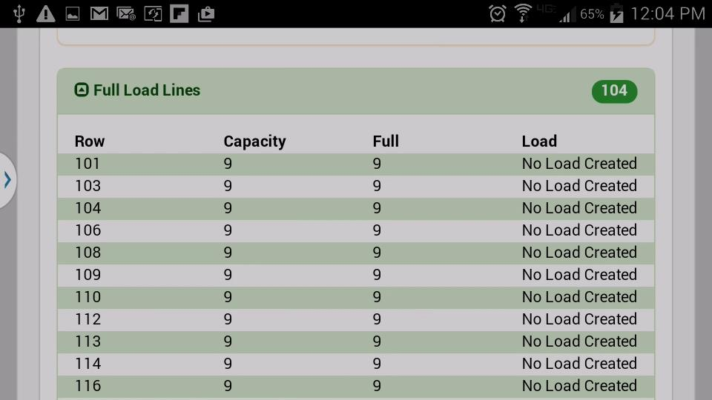
If you see this message, click the root menu icon and select “Settings”. Follow the instructions under Settings from this guide to add preferred locations.

Settings
Under the Settings root menu, the user can add preferred locations to their profile. This will narrow down the locations returned in reports and drop downs for the mobile app to ones that the user selects. This will be a subset of locations from the user’s VASCOR FVS Location Security Privileges.
First the user will select Customer. This will load the locations the user has access to under the selected customer. Then type to filter or click the location name to add/remove from their preferred location list.
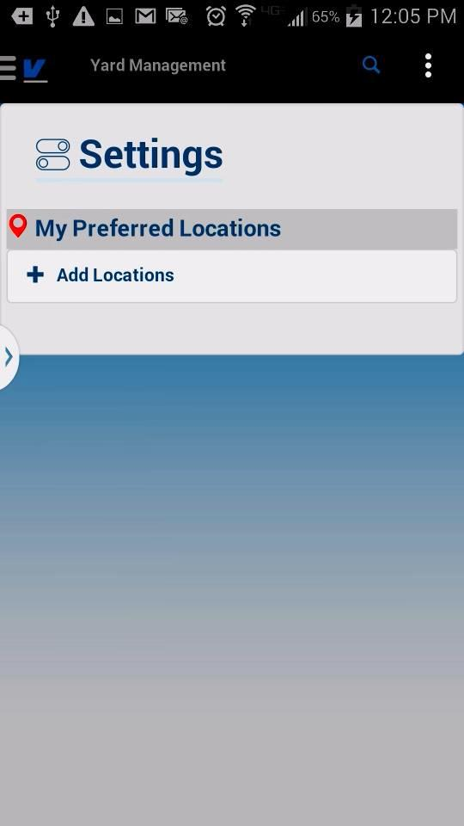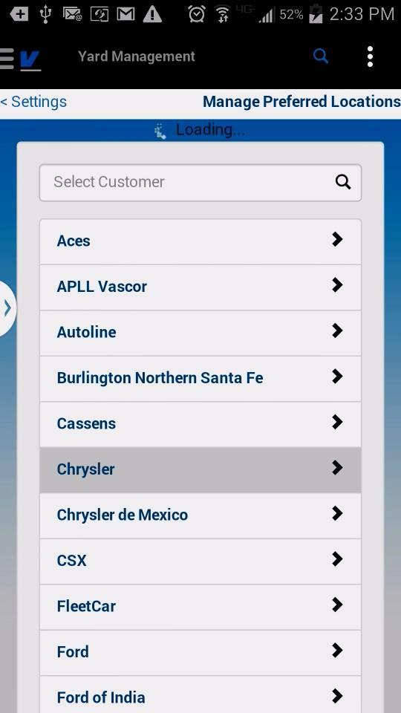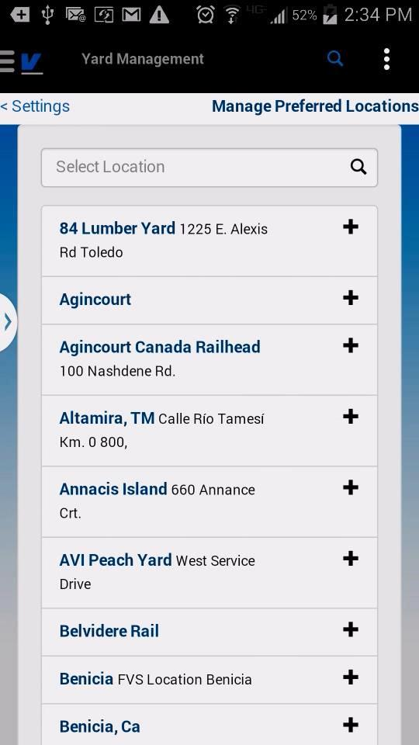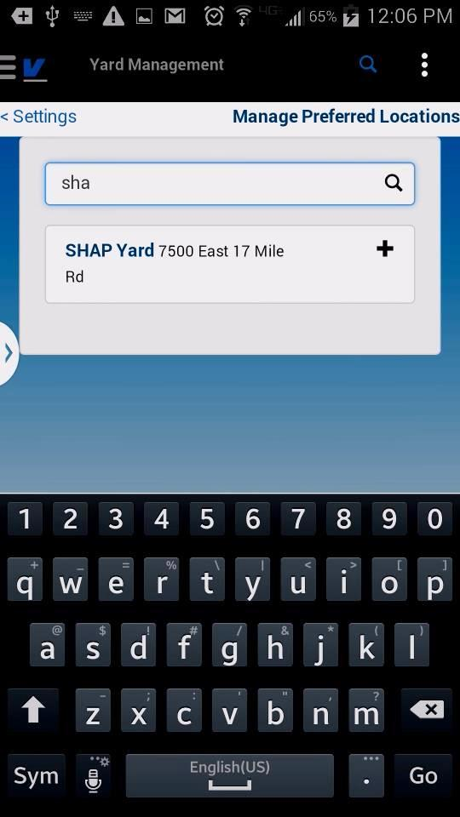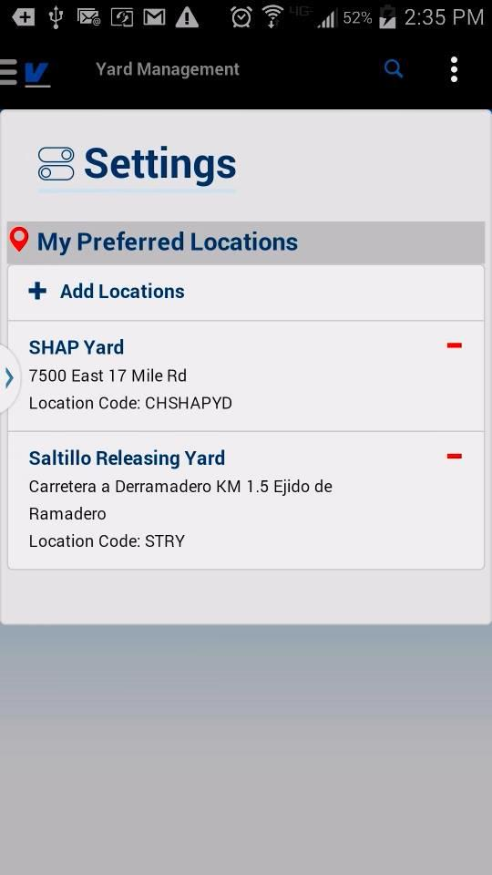

Recent VINs
Recent VINs is a list of the last 10 vehicle searches made by the currently authenticated user to the Yard Management Search.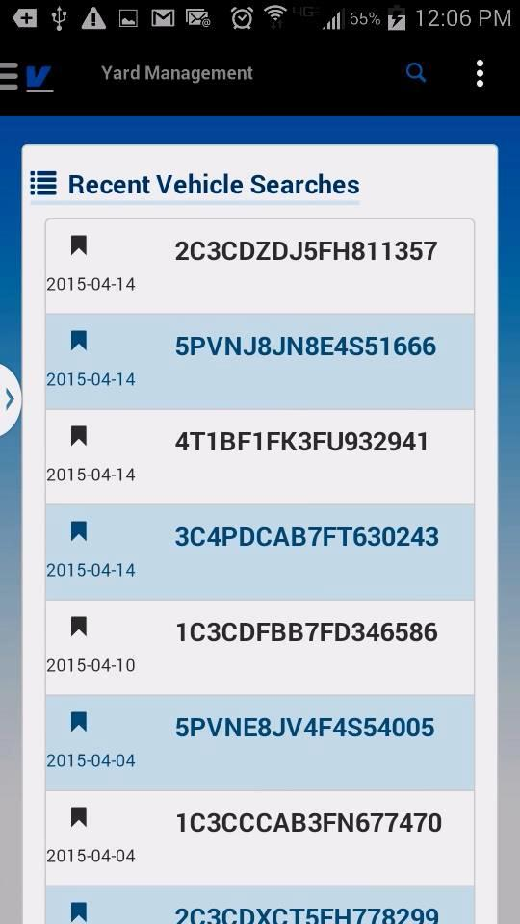
Click the VIN row to reopen the VIN Details for the vehicle.

Total Inventory Report
This report is a mobile version of the VASCOR FVSCMS Web Based Management Reports/Total Inventory By Location
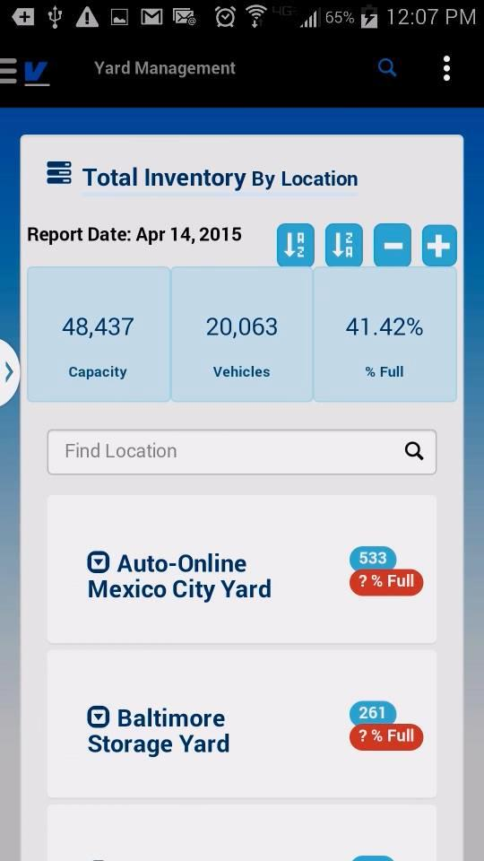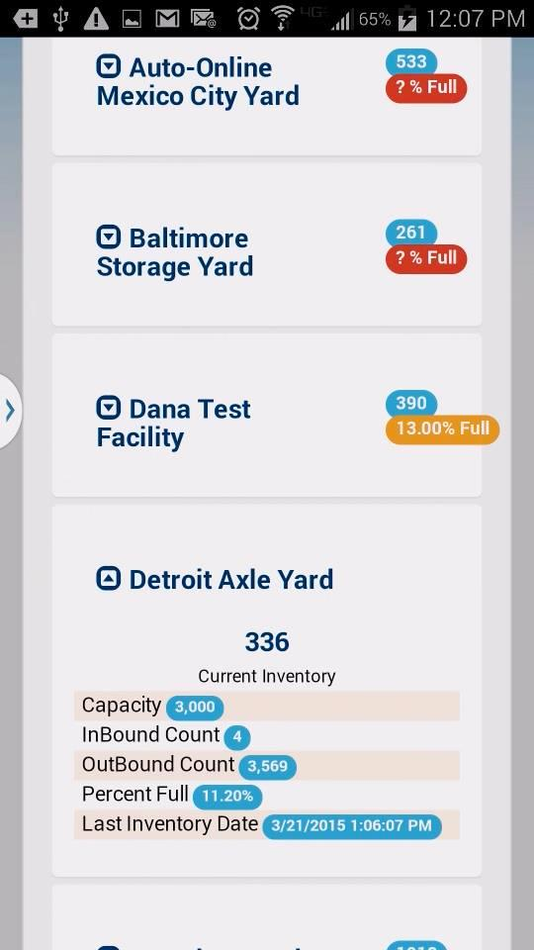
Button row to sort/expand-collapse all locations
Type to filter location name
Click Location Name to view specifics

Yard Activity Summary Report
FVSMobile version of the FVSCMS Web based Activity Summary Report. This report for a selected date will show activity/events for the authenticated user’s preferred locations.
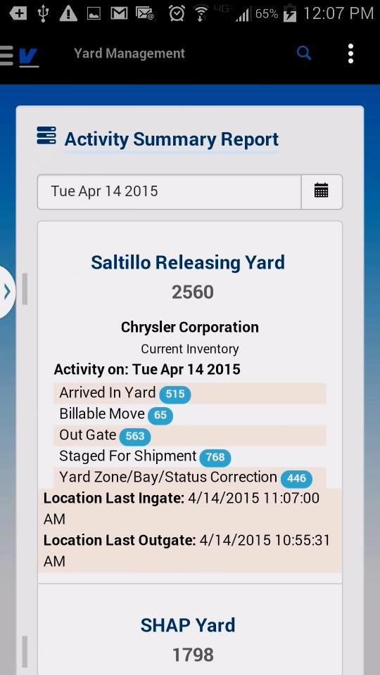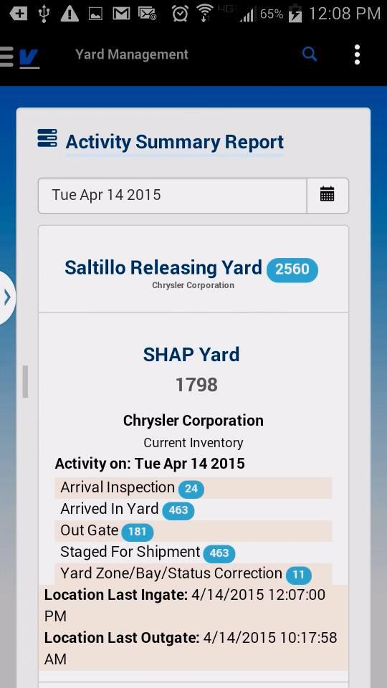
Click calendar to change date
Touch Name to collapse/expand details

Rail Services

Rail Loading Summary
Productivity report for the number of vehicles/rail cars that were loaded during a given interval. The metrics of the report show the number/percentage of loaded that have been departed. The drill in to the track/loading date allows the user to drill in to the rail car and see the list of vehicles and their position.
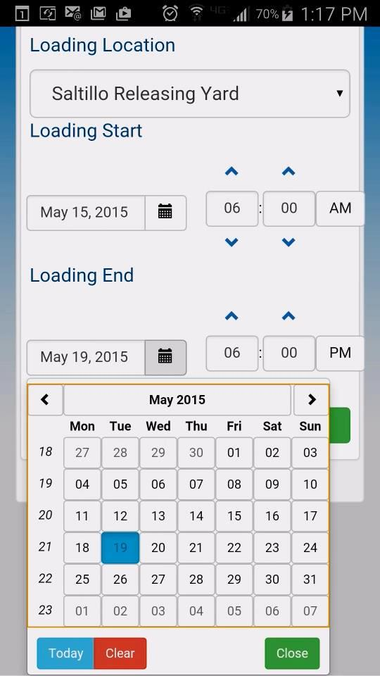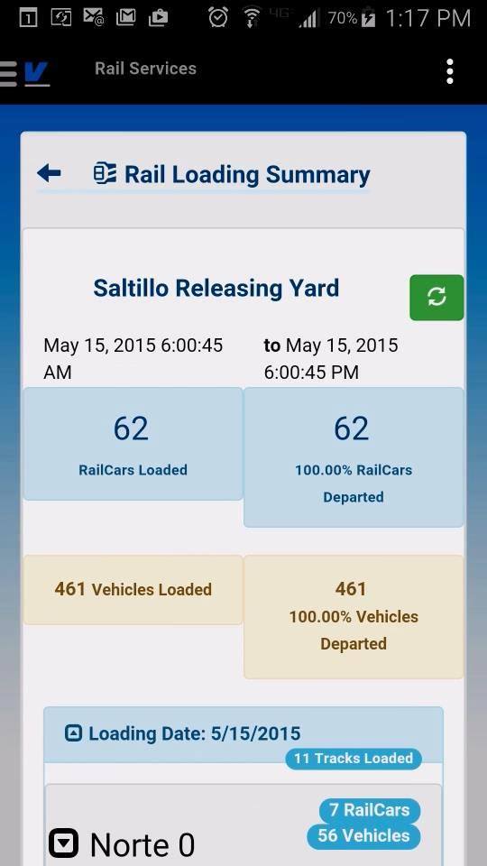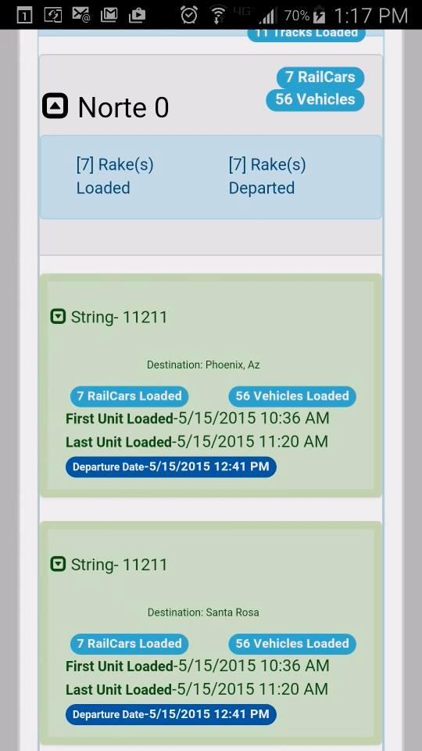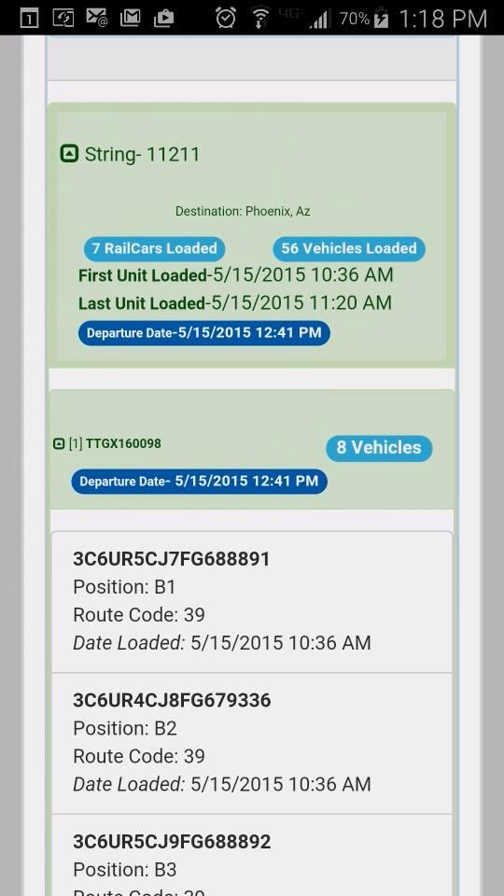

Rail Loading Dashboard
The Rail Loading Dashboard displays live loading metrics for the selected user preferred location. The module displays the current daily metrics for number of Railcars/Vehicles Loaded, Departed and all currently Awaiting Departure. The summary details the last unit loaded, the track and railcar it was loaded on, the date/time and unit position on the railcar. The dates on this dashboard have been converted to the user’s local time. This summary also displays the last departed string at the location, it’s date and time and which track it was departed from. Note: The Saltillo Releasing Yard dashboard, the daily range begins at 6a.m. CST to next day at 5:59 a.m. CST

Below the daily summary is the current track activity, It displays the last known activity on the track. If a string has been built on the track it will show it’s loading status, if there is no pending string, it will show the last departed string’s information. 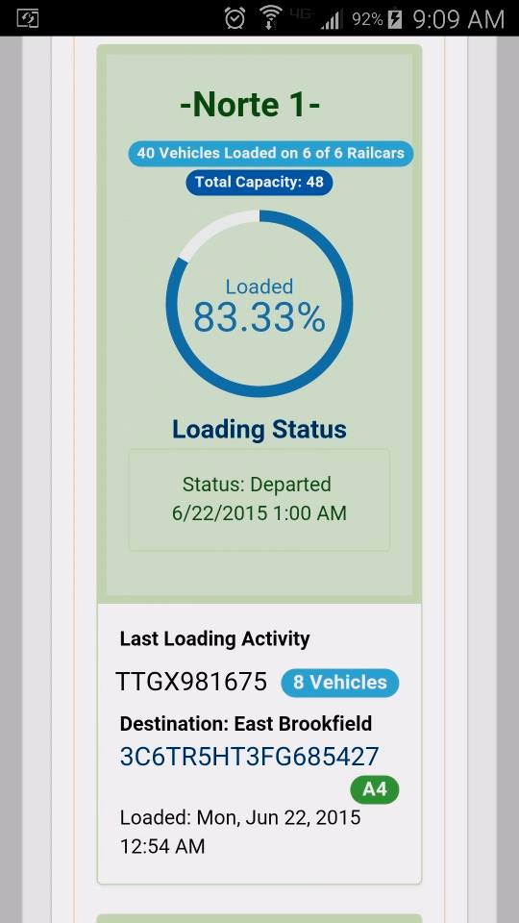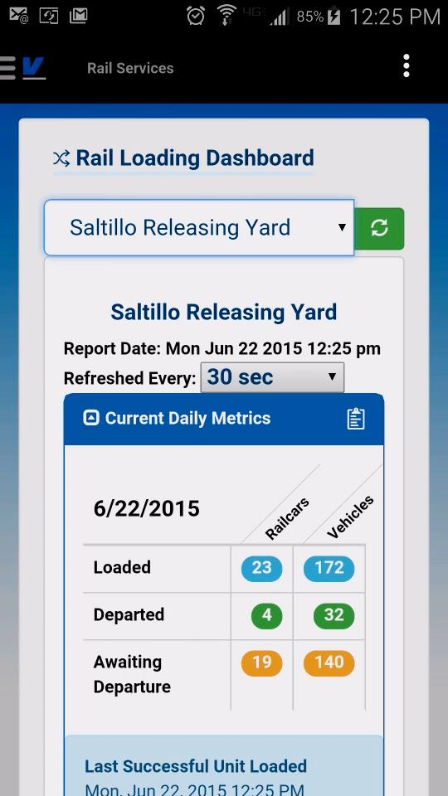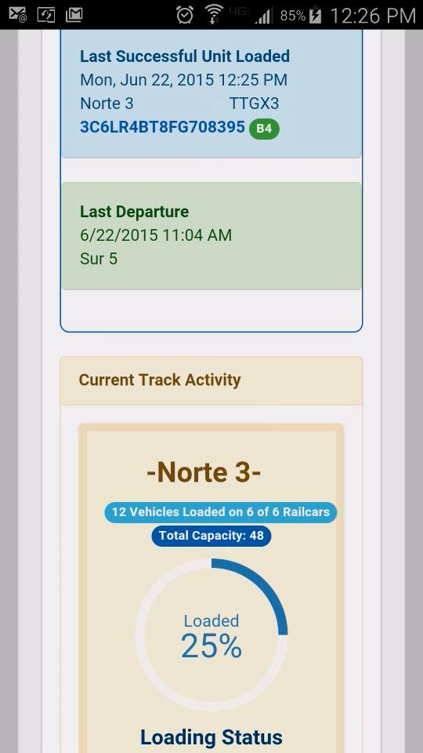

Damage Prevention

Vehicle Inspection Search
To view a vehicle’s inspections from DP (Damage Prevention) select Damage Prevention from the root menu and then click the magnifying glass icon on the top right menu bar.
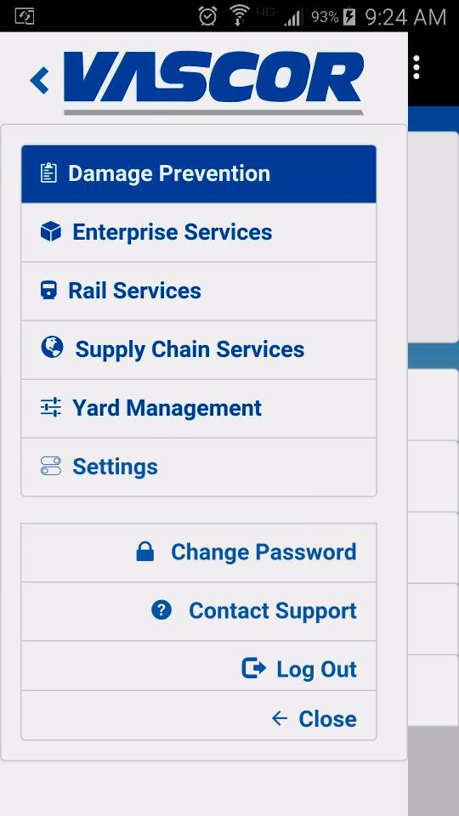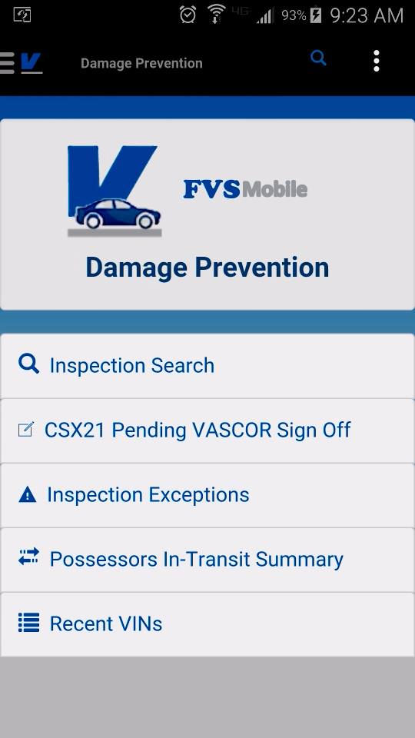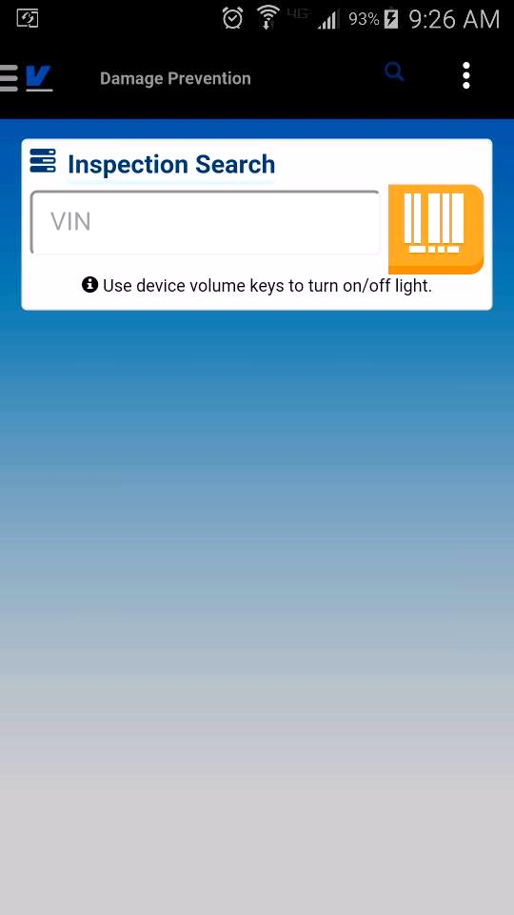
Search Icon- touch to bring up Inspection Search screen
Touch here to bring up optical barcode reader.
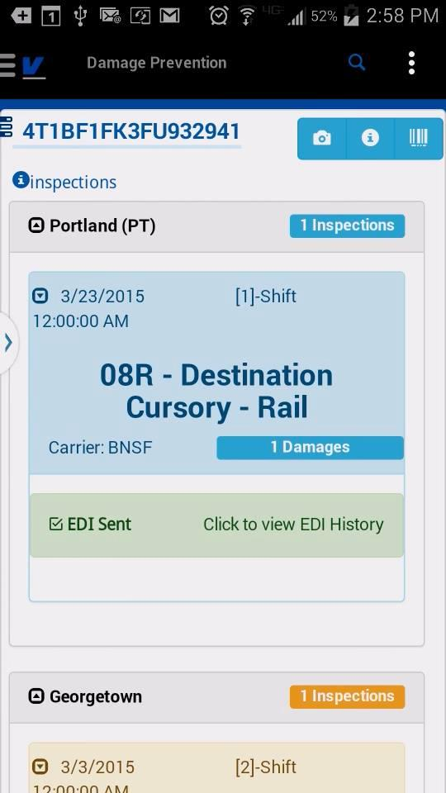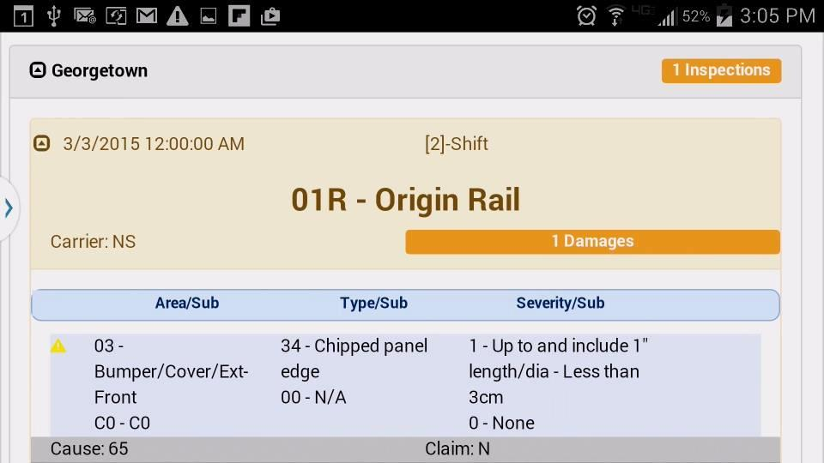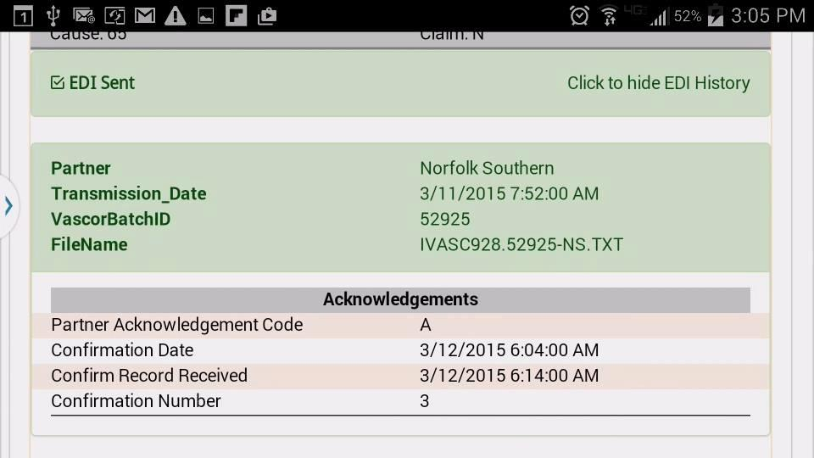
Touch Inspection Header to view damage details
- Vehicle Inspections
  - All inspections grouped by location, ordered by date
  - Inspections are color coded according to max damage severity, blue is informational, yellow and red denote damage.
  - Click Locations to expand/collapse inspections list
  - Click Inspection Header to view Damage details
  - Shows whether EDI has been sent for the inspection
  - If User has appropriate privileges, they can click to expand EDI Sent to view the list of transmissions and acknowledgements from the partner.

If assigned security privileges for EDI History, can click to view partner details, date sent and any acknowledgements received.

Transit History
Vehicle Possessor Information combined with our FVSCMS Supply Chain information for drive away events and non-inspection loads.
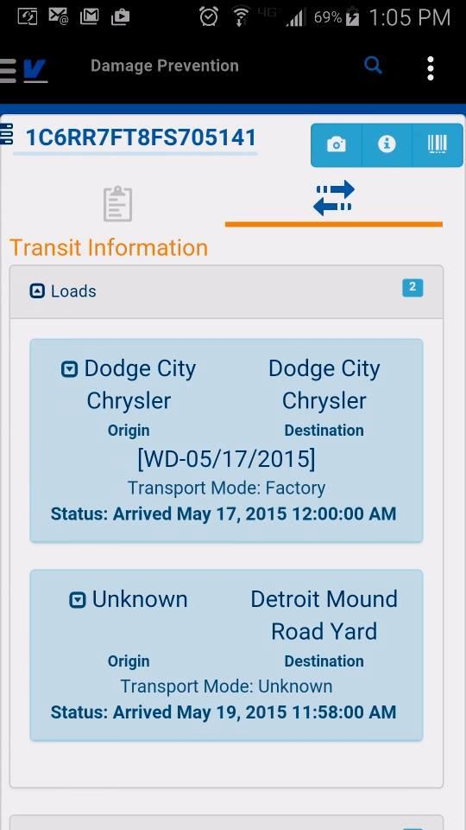

CSX21 Report VASCOR Sign-Off
VASCOR CSX21 Report Signoff can be managed through the FVSMobile app, from the damage prevention menu, the option for CSX21 Pending VASCOR Sign-Off shows the user the report of items that are pending supervisor sign off. Clicking into the report, the user can manage the report, view images associated, email the report to other FVS Users and also approve/reject the report.
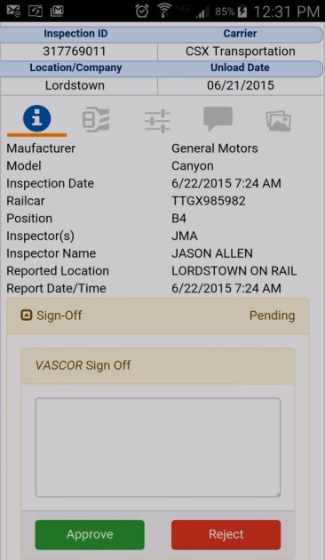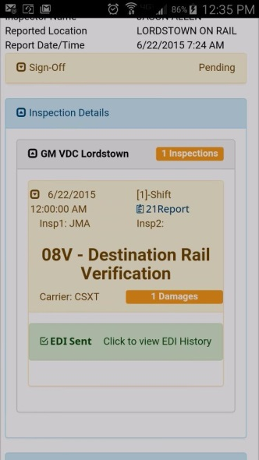
Users with access to the 21 Report will also see a link the 21 report details module from Damage Prevention VIN Inspection Details screen.

Inspection Exceptions (PDT Rejects)
For locations assigned to the user account, the summary details the number of exceptions for each location. Clicking on the name will detail what the error list is, and further breakdown allows the user to reprocess, edit or delete the inspection (with correct security privileges).
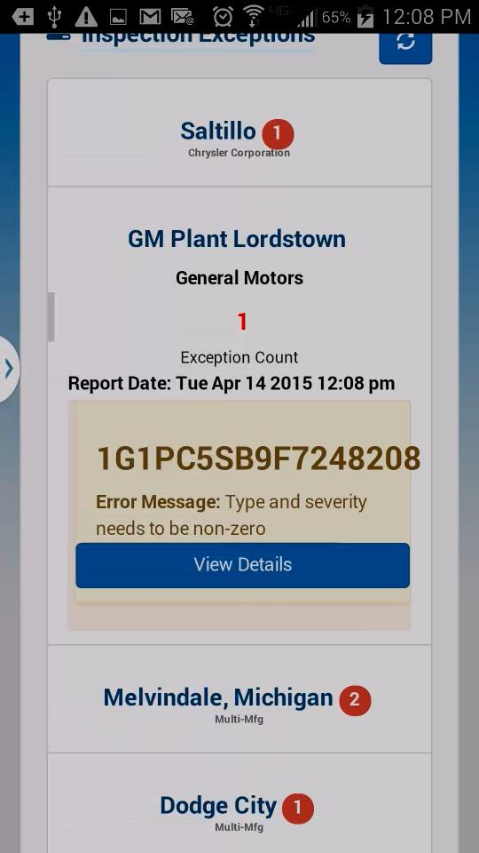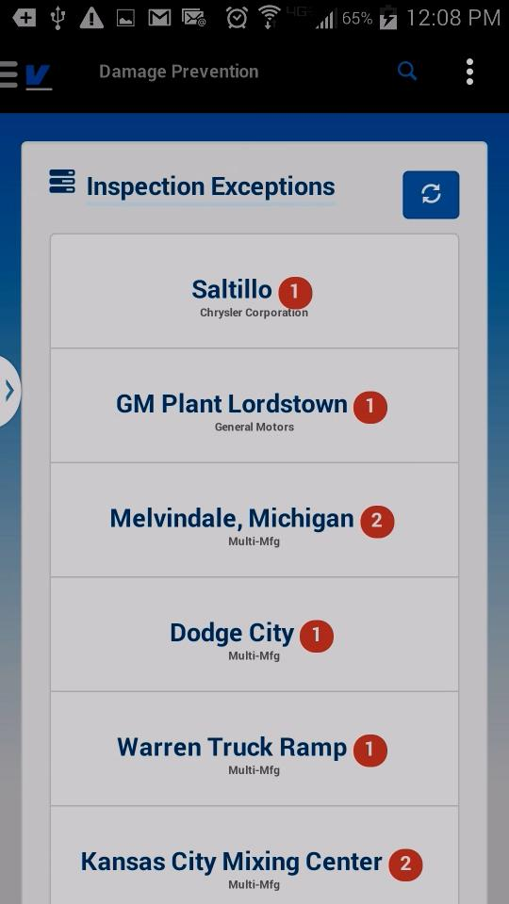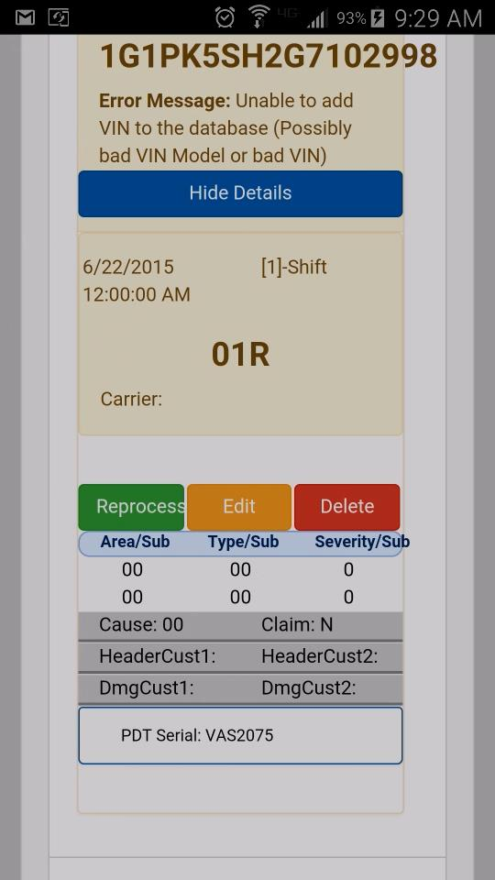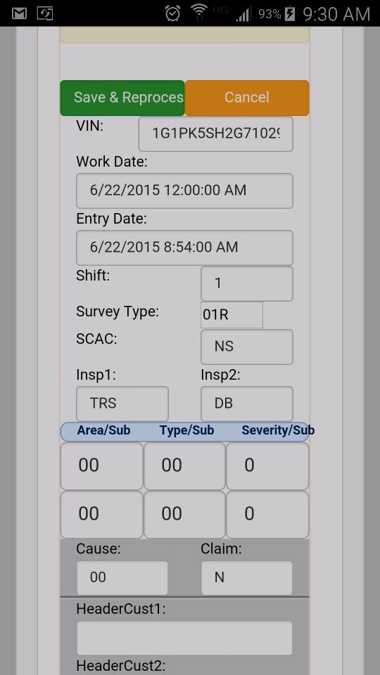

Possessors In-Transit
For arriving possessors to a location, the Possessor In-Transit Summary screen lists the user’s locations and the number of possessors in transit to that destination. Clicking on the location name will direct the users to the Arrive Possessors screen. This will show the user the list of possessors in transit to that destination and allow the user to select, update securement and arrive with the selected date.
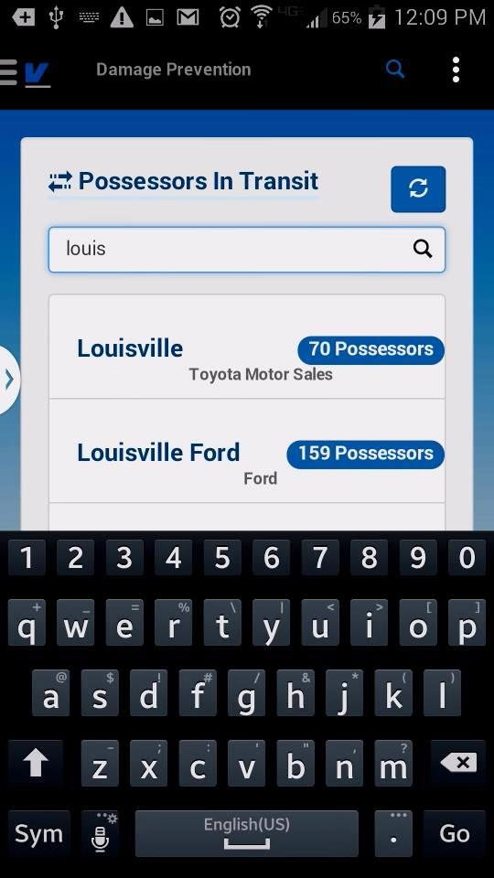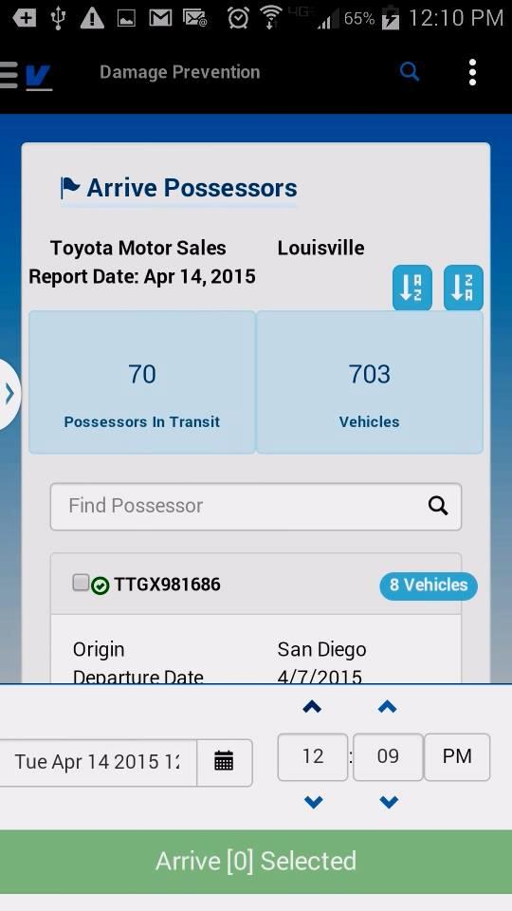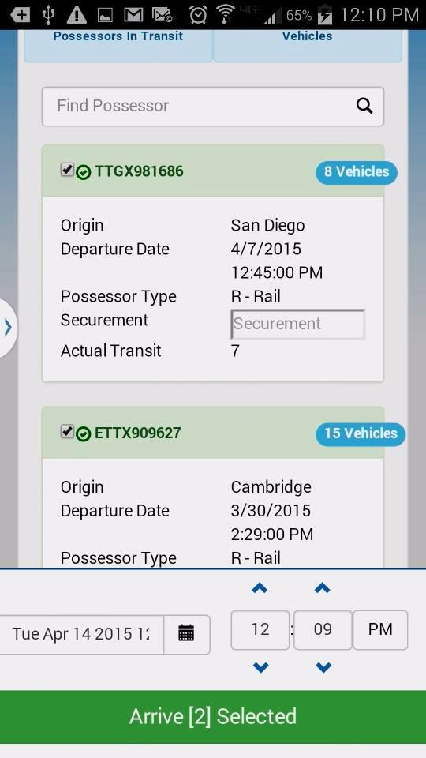

Recent VINs (Damage Prevention)
Shows the last 10 Inspection Vehicle searched performed by this user account on the device. Clicking any VIN in the list will show the inspection details screen for the vehicle.
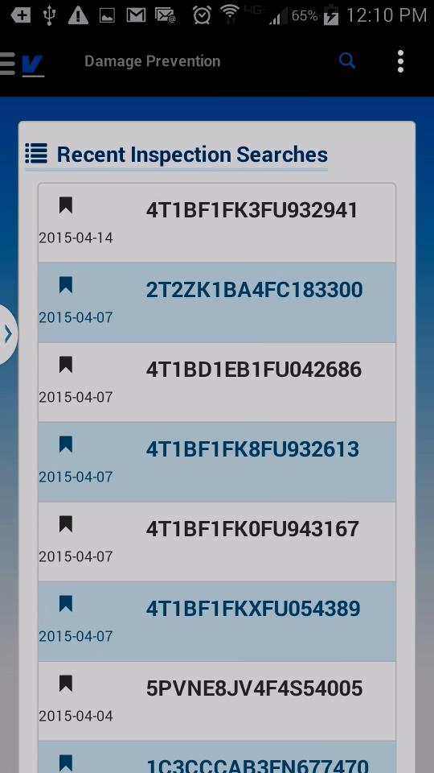

Settings
The settings screen allows users to manage their System Preferred Locations. These configured locations appear as the options available inside of the mobile drop down menus for Location. If a user attempts to view a report with a location input and they do not have any locations configured, they will receive a message to visit the settings module to add locations.
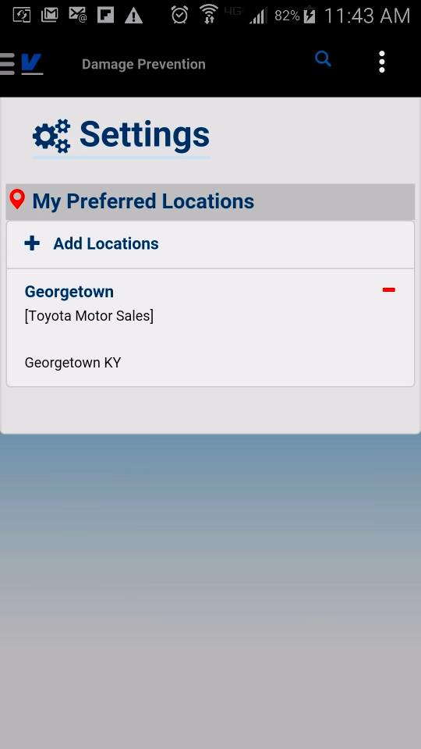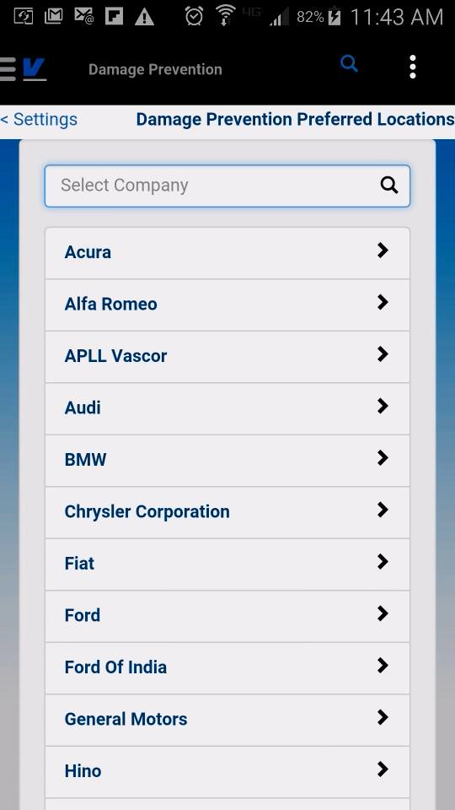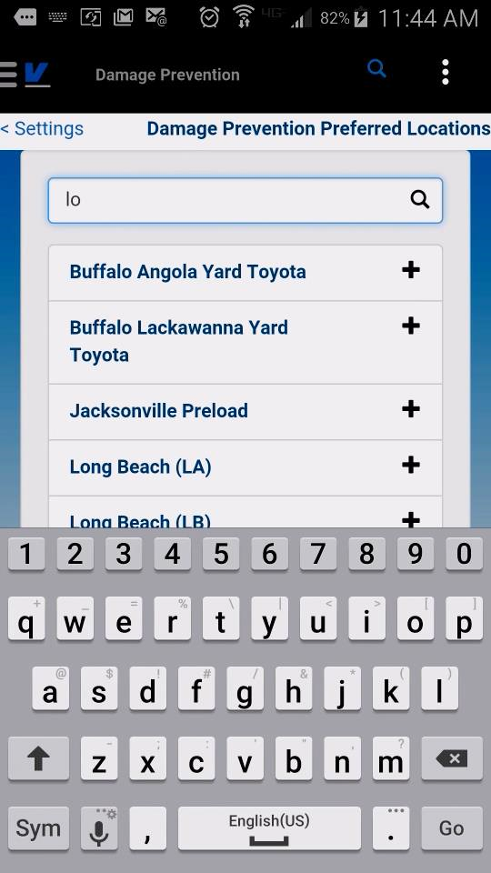
Select a Company, then the list of available locations your account has access to will appear. Filter and click to add.

Inspection Volume Report
The inspection volume report displays for a range of time at a location and selected data grouping, the number of inspections completed and number of inspections with damages by Survey Type, Shift and VIN Model.
User may enter their own filter to narrow the data even further by Survey Type or VIN Model from the results screen. 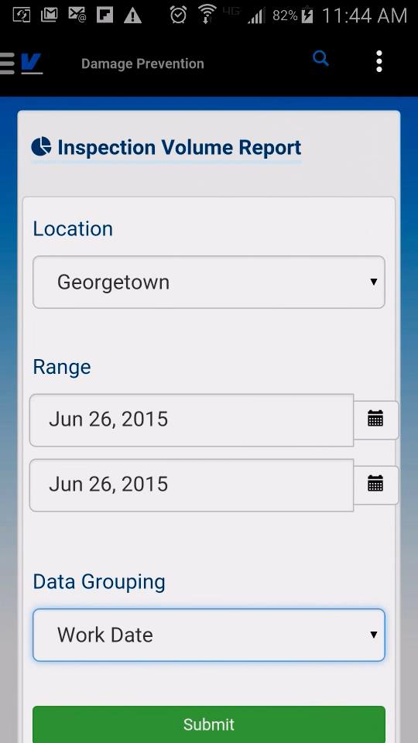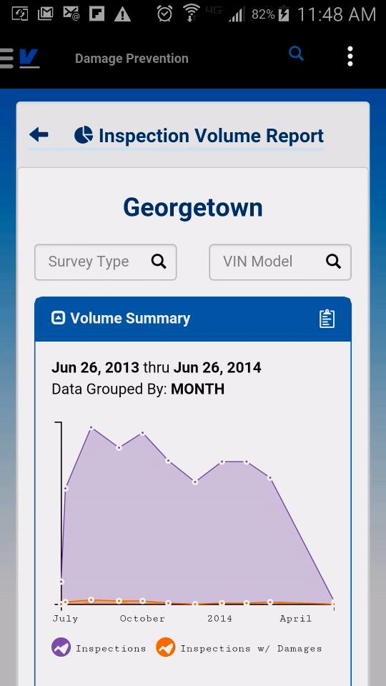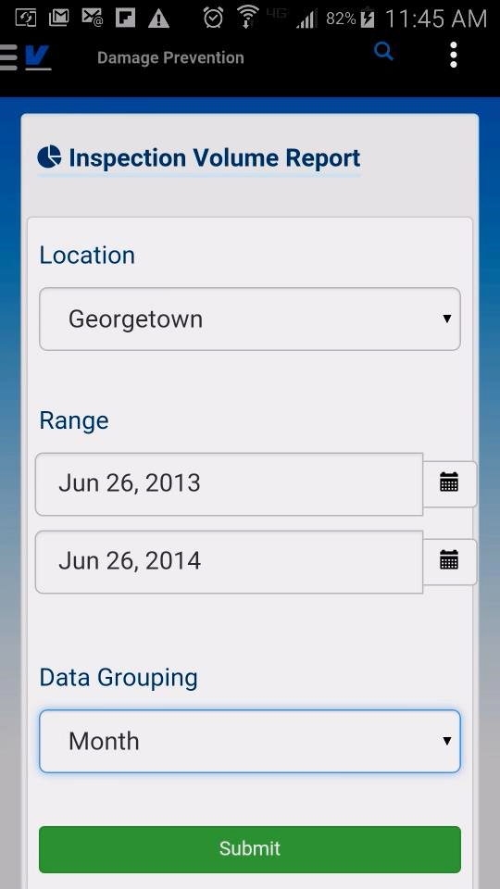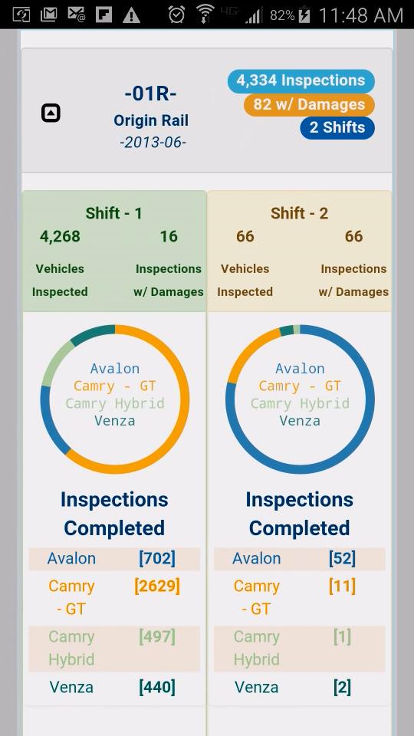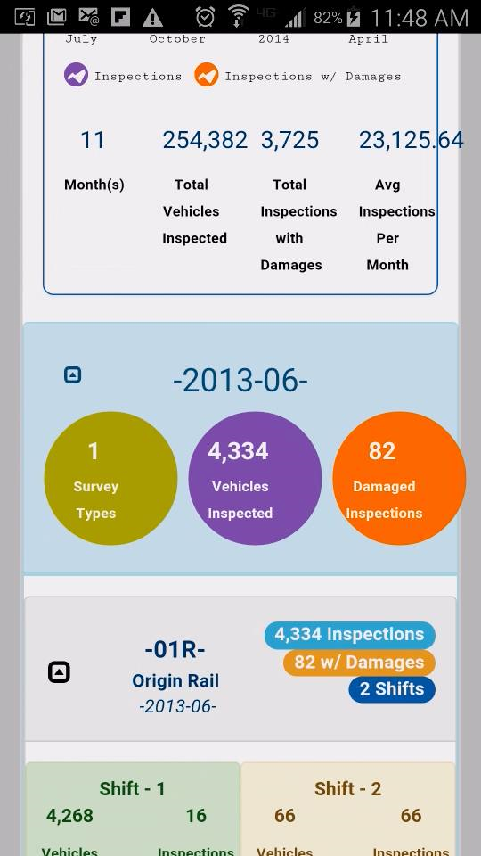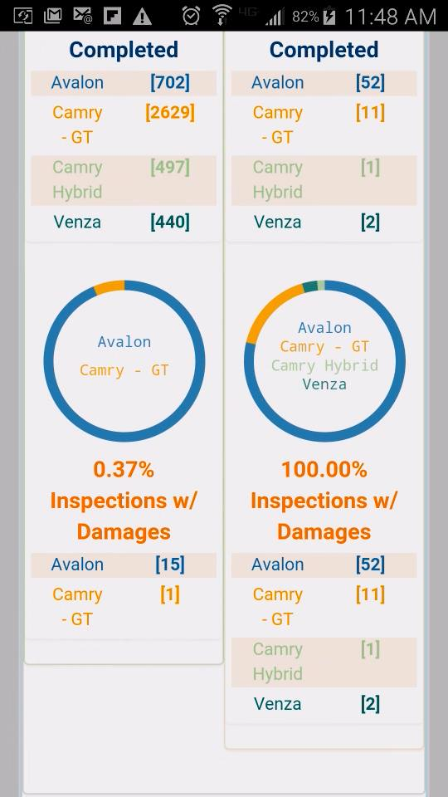

Supply Chain Services
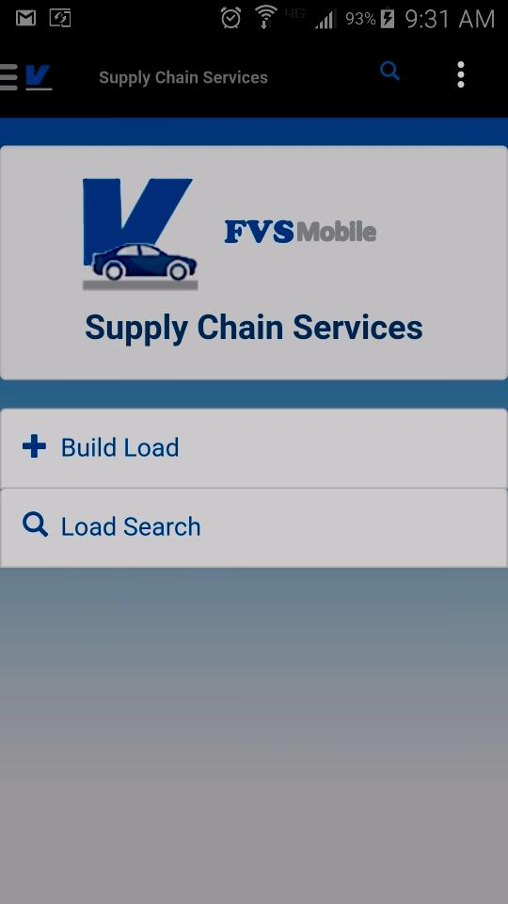

Load Search
Users may scan or enter VIN/last 8 of VIN, token, or Load ID to retrieve matching loads. Selecting a load from the results list, or if only one load is found, will direct the user to the Load Details module.
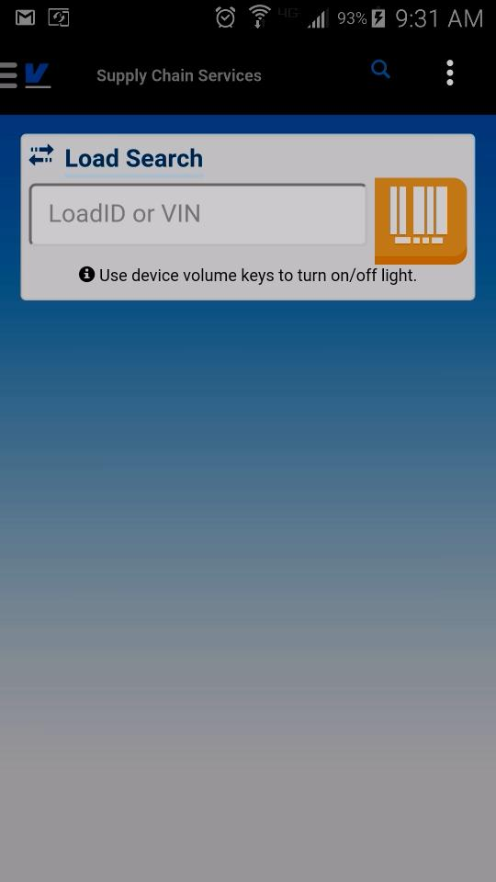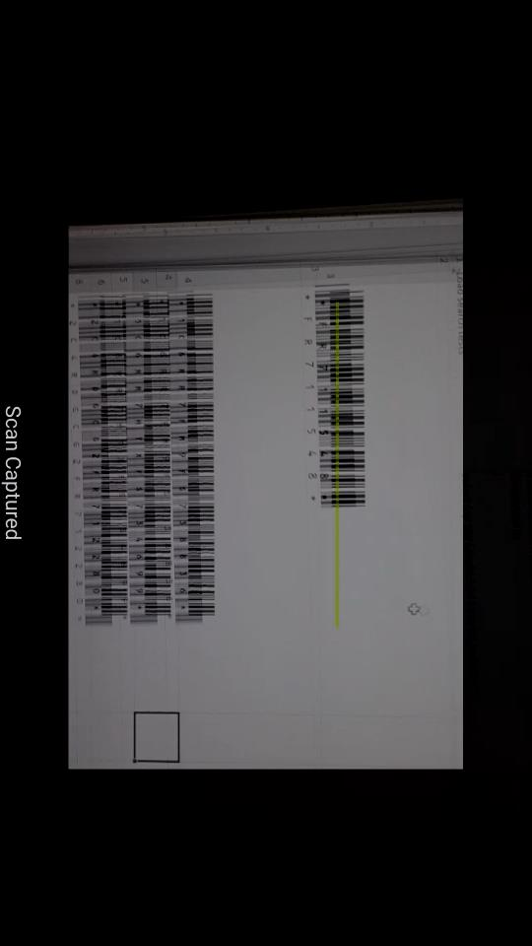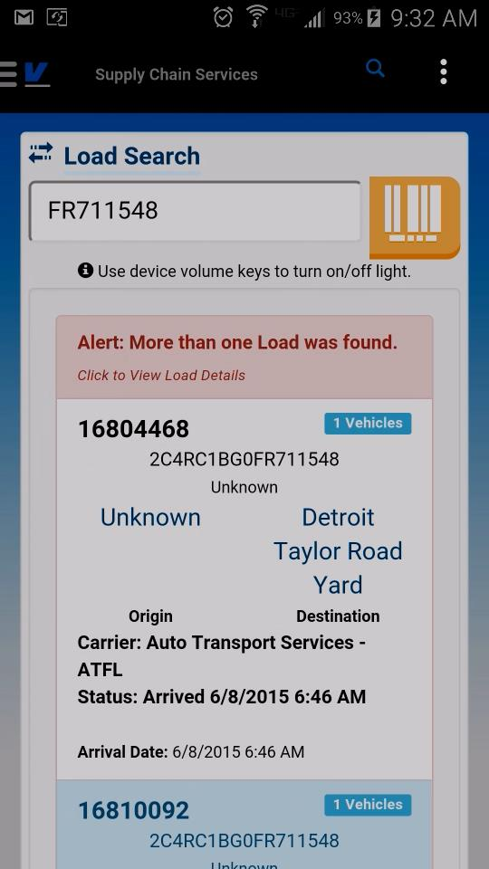

Load Details
This screen allows users to manage transit load information. They can: edit the load and vehicle information, add/remove vehicles on the load, Arrive/Depart individual vehicles or the entire load.
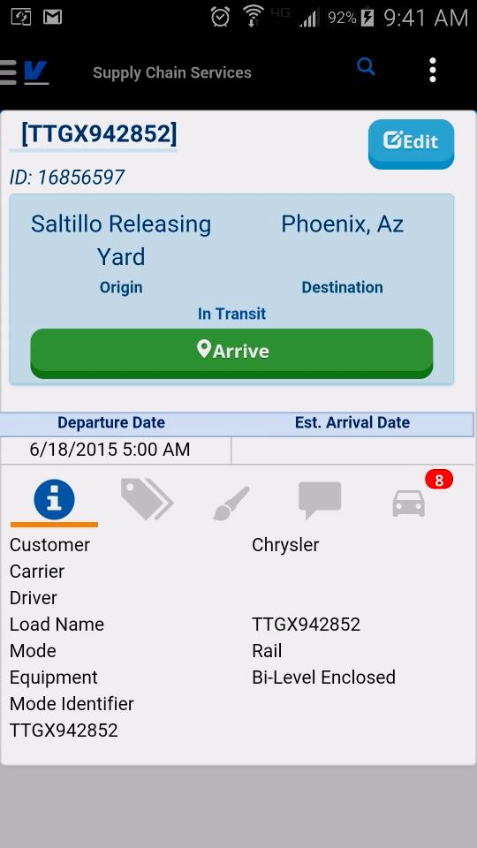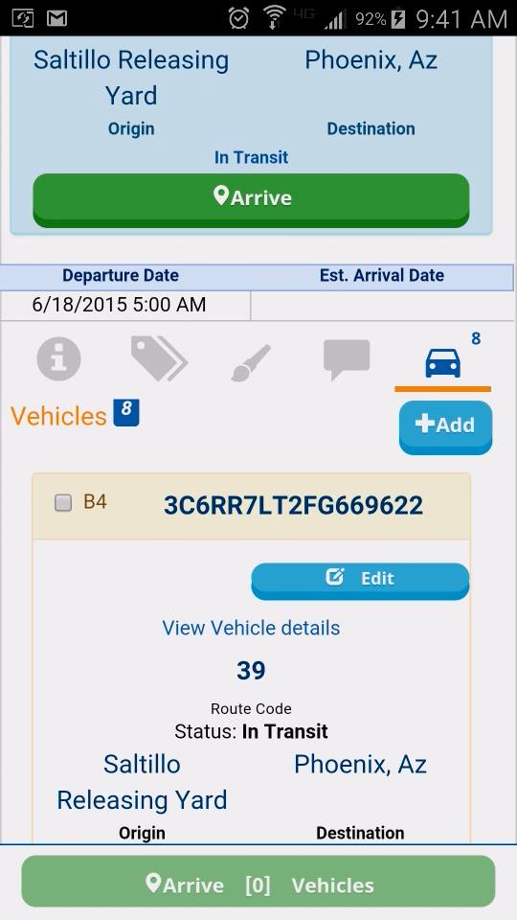

Build Load
The load building screen ties into the load details screen, allowing users to create a load from their device, add vehicles to the load by scanning the VIN or entering the last 8/Token of the VIN.
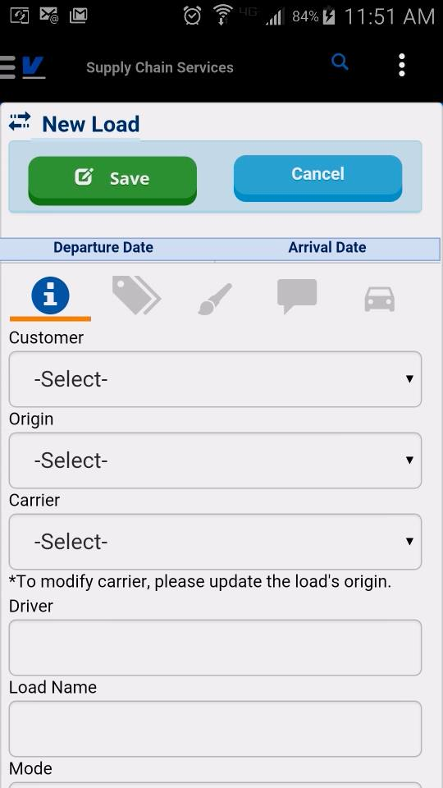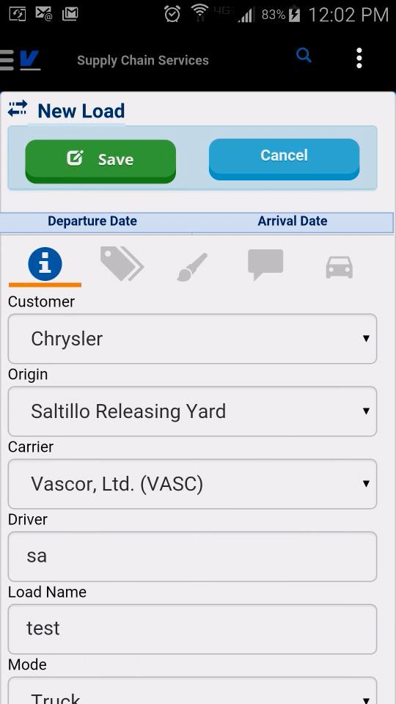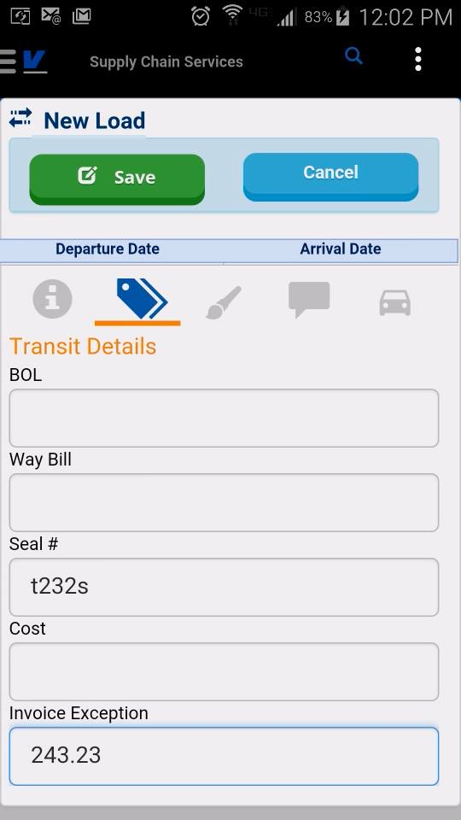
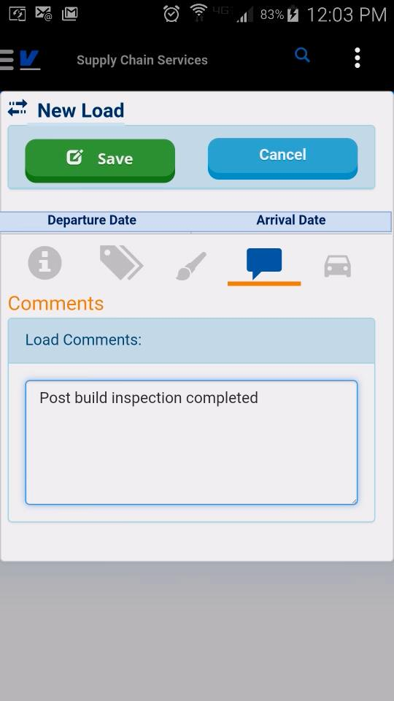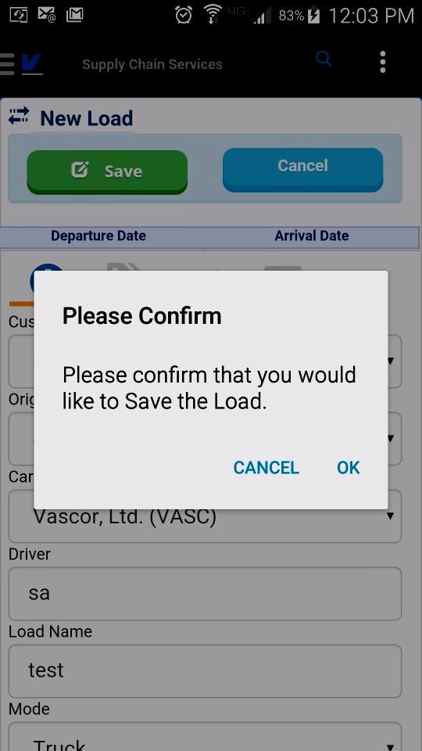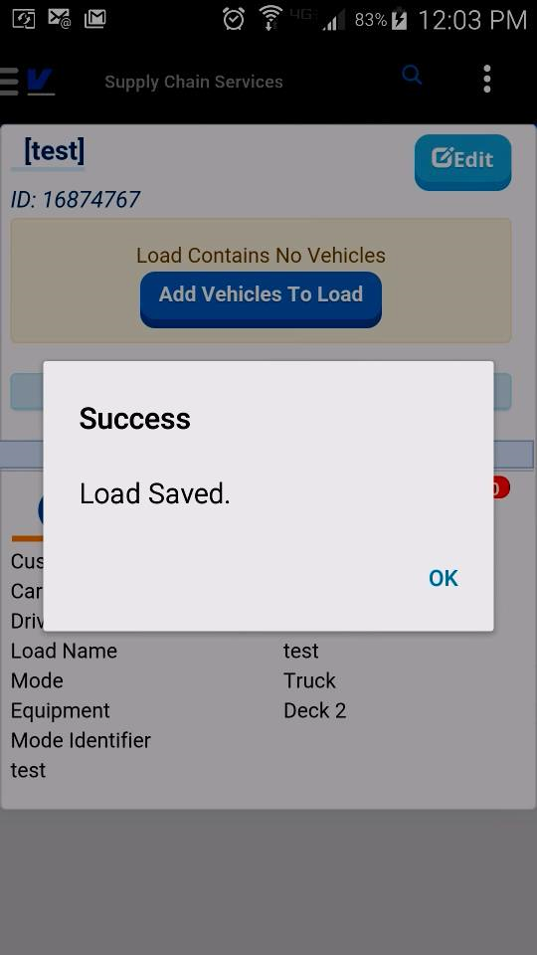

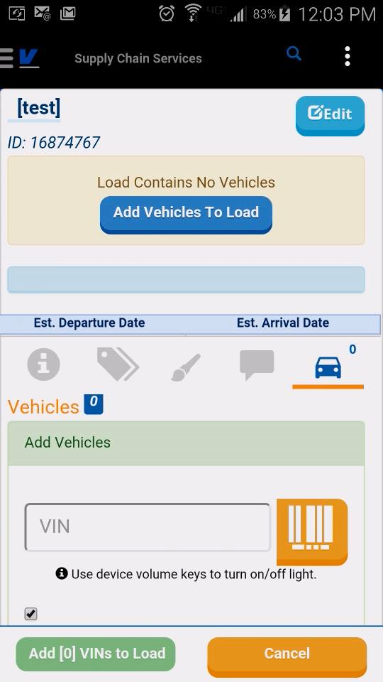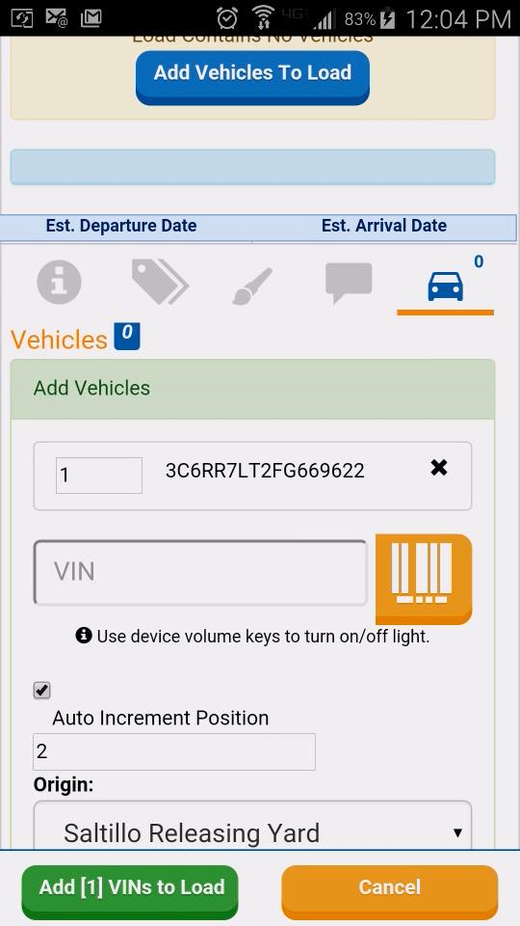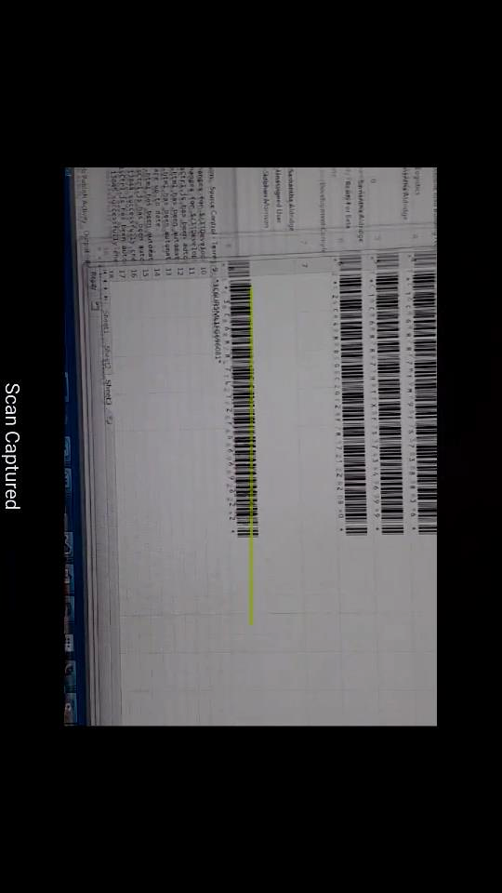
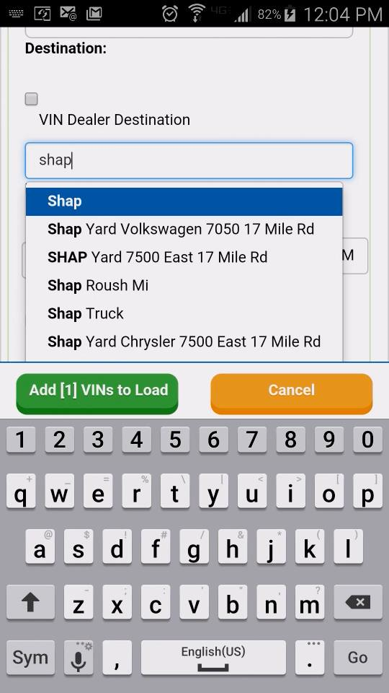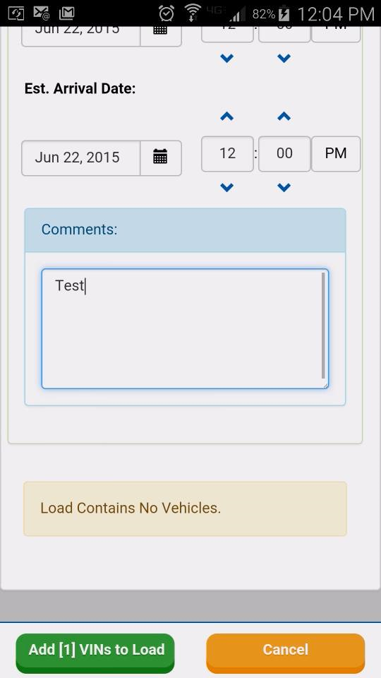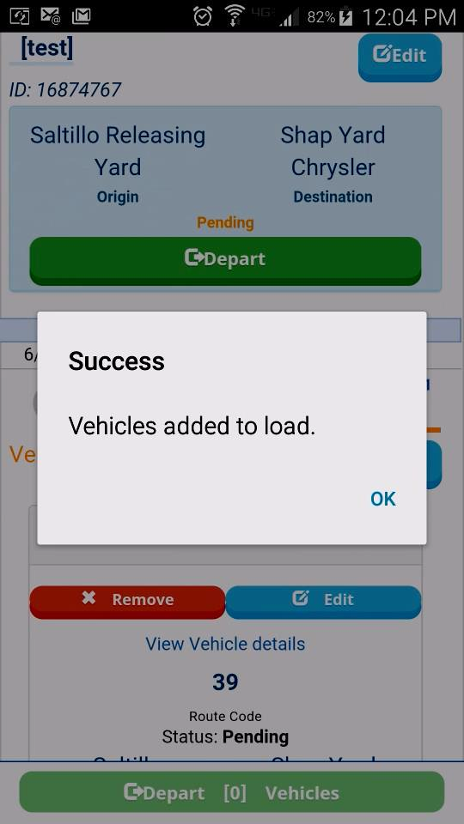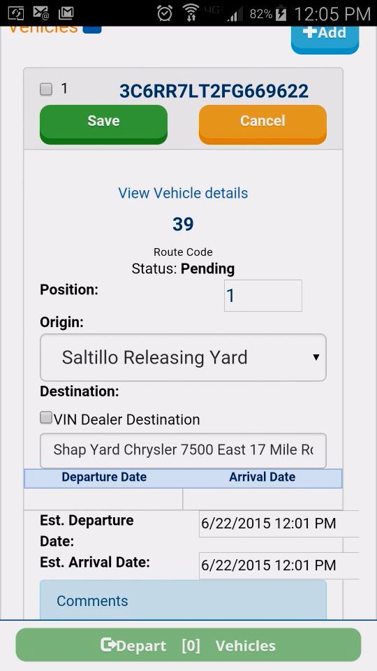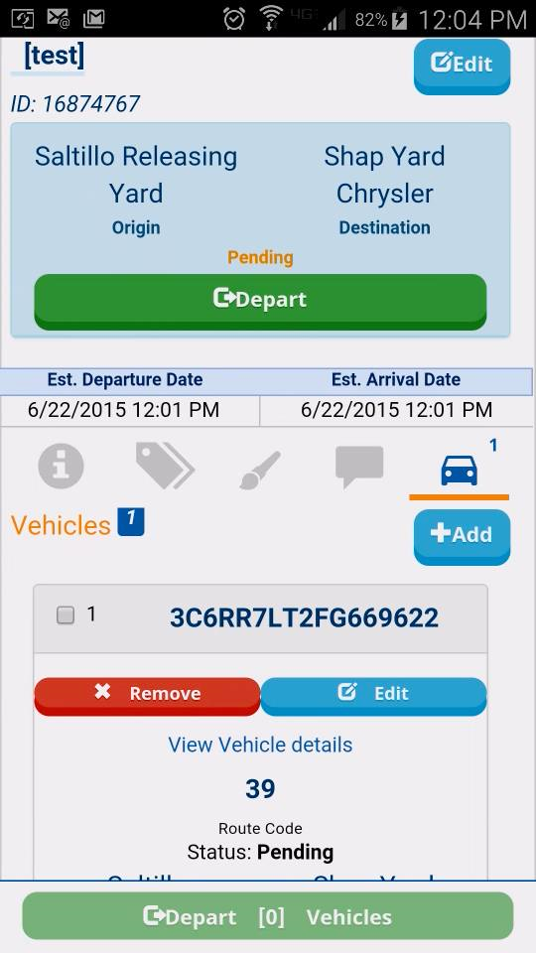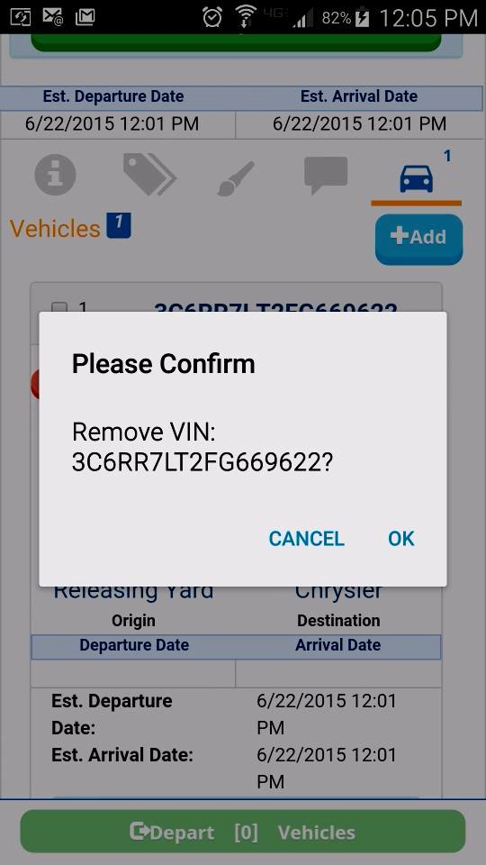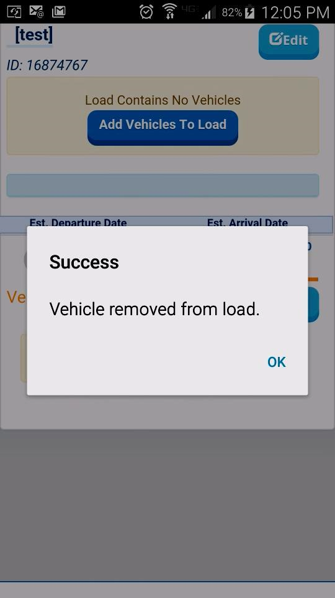
User may select destination as VIN Dealer and value will automatically be populated, or they can type to select a location.
Once Vehicles have been added to the load, they can be edited, removed or individually selected to be departed.

Additional Information

Barcode Scanner
The barcode scanner component supports the following barcode formats:

Android
- QR_CODE
- DATA_MATRIX
- UPC_E
- UPC_A
- EAN_8
- EAN_13
- CODE_128
- CODE_39
- CODE_93
- CODABAR
- ITF
- RSS14
- PDF417
- RSS_EXPANDED

iOS
- QR_CODE
- DATA_MATRIX
- UPC_E
- UPC_A
- EAN_8
- EAN_13
- CODE_128
- CODE_39
- ITF

Feature and Enhancement Requests
FVSMobile 1.6.0.0 is in Evaluation Status. If you have questions, comments or feature requests please send them to ITDevelopment@vascorltd.com subject: FVSMobile

